B2 CELLS
2.2 Movement into & out of Cells

- Define Diffusion.
Diffusion is the net movement of molecules from a region of their higher concentration to a region of their lower concentration down a concentration gradient, as a result of their random movement.

- Describe the importance of diffusion of gases and solutes and of water as a solvent.
Factors that help diffusion are as follows:
- Distance (the shorter the better) e.g. thin walls of alveoli and the capillaries.
- Concentration gradient (the bigger the better). This can be maintained by removing the substance as it passes across the diffusion surface.
- Size of the molecules (the smaller the better).
- Surface area for diffusion (the larger the better) e.g. there is millions of alveoli in a lung, giving a huge surface area for diffusion of oxygen.
- Temperature (molecules have more kinetic energy at higher temperatures).

Importance of diffusion of gases and solutes:

Substance diffused | Site of diffusion
Oxygen | From the alveoli into blood capillaries
Carbon dioxide | From blood capillaries into the alveoli.  From air, through stomata & into the leaf for photosynthesis.
Soluble products of digestion | From small intestine to the blood capillaries.
Scent made of tiny molecules | From flowers into the bee’s body.

Importance of water as a solvent:
- Most cells contain about 75% of water;
- Many important metabolic reactions take place in aqueous solution;
- Many substances move around a cell dissolved in water (and also around organisms, e.g. in blood, xylem & phloem).

- Define Osmosis
Osmosis is the diffusion of water molecules from a dilute solution to a more concentrated solution through a partially permeable membrane.

- Describe the importance of osmosis in the uptake of water by plants, and its effect on plant and animal tissues.

Importance of osmosis in the uptake of water by plants:
- Usually, the water in the soil is more dilute than that in root hair cells
- So water enters root hair cells by osmosis (a passive process – requiring no energy)

Effects of osmosis on plant and animal tissues:
- When placed in pure water, plant and animal cells will take in the water by osmosis;
- This is because there is a higher concentration of water molecules outside the cell than inside it;
- Plants become turgid, but do not burst because of their tough cell wall;
- Animal cells will burst, because they have no cell wall;
- The reverse happens when plant and animal cells are placed in a concentrated sugar or salt solutions. This is because there is a higher concentration of water molecules inside the cell than outside it;
- Plant cells become flaccid and the cytoplasm is no longer pressed against the cell wall;
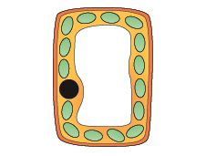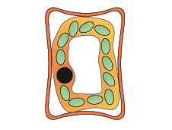
Turgid plant cell Flaccid plant cell

- Animal cells also become flaccid and their shape changes- they can become crenated.

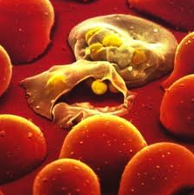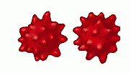
RBC burst Crenated RBC

- Describe and explain the importance of a water potential gradient in the uptake of water by plants.

- Water potential is the correct term for saying ”water concentration” a high water potential is equivalent to a low solute concentration and vice versa;
- For plants to take in water through their roots they must have a high solute concentration or low water potential in the roots and low solute concentration or high water potential outside the roots.
- In osmosis, water molecules diffuse down a water potential gradient.

