B4 NUTRITION
4.2 Plant Nutrition

1. Define photosynthesis - the fundamental process by which plants manufacture carbohydrates from raw materials using energy from light.

2. Explain that chlorophyll traps light energy.
- Chloroplasts containing chlorophyll are responsible for trapping light energy.
- This energy is converted to chemical energy for the formation of carbohydrates (glucose);
- Glucose is usually changed to sucrose for transport around the plant, or to starch for storage;
- Oxygen is released as a waste product, or used by the plant for respiration.

- State the word equation for the production of simple sugars and oxygen
- State the balanced equation for photosynthesis in symbols
Light
Carbon dioxide + water Glucose + oxygen
Chlorophyll
Light
6CO₂ ₊ 6H₂O C₆H₁₂O₆ + 6O₂
Chlorophyll

- Investigate the necessity for chlorophyll, light and CO₂ for photosynthesis, using appropriate controls.
- Experiments can be used to find out what factors are needed for photosynthesis.
- First the plant is destarched. This involves leaving the plant in the dark for 48 hours. The plant uses up all the stores of starch in its leaves (in respiration).
- One plant (or leaf) is exposed to all the conditions needed- this is the control.
- Another plant (or leaf) is deprived of one condition (this may be light or carbon dioxide).
- After a few hours the starch test is carried out on the control and the test plant/leaf.

TESTING A LEAF FOR STARCH
The starch test does not work by placing iodine solution on fresh leaves, it is not absorbed.

STAGE | REASON | SAFETY POINTS
Boil the leaf in water | To break the cell membranes, this makes it permeable | Danger of scalding
Boil the leaf in ethanol | To decolorize the leaf- chlorophyll dissolves in ethanol | No naked flames- ethanol is highly flammable
Rinse the leaf in water | Boiling the leaf in ethanol makes it brittle- water softens it
Leaf the leaf out on white tile | So that the results are easy to see
Add iodine solution to the leaf | To test for the presence of starch | Avoid skin contact with iodine solution

Experiment 1 - To see if chlorophyll is needed for photosynthesis
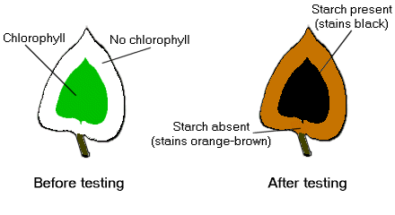
Steps involved:
- Leave a plant with variegated leaves (green and white) in a warm, sunny spot for a few days.
- Test the leaves for starch (the control is the green part of the variegated leaf; the experimental leaf is the white part of the variegated leaf)
Result: green part will give a positive test for starch due to the presence of chlorophyll

Experiment 2 - To see if carbon dioxide is needed for photosynthesis
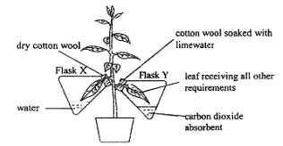
Destarch a plant. Set up the experiment as shown in the figure. Test the leaves for starch.
Control is the flask with leaf & distilled water.
Experimental leaf shows the absence of starch as it is deprived of carbon dioxide due to the presence of potassium hydroxide or limewater
Experiment 3 - To see if light is needed for photosynthesis
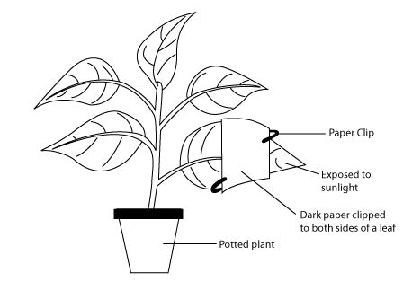
Destarch a plant. Set up the experiment as shown in the figure. Test the leaves for starch.
Control is the uncovered part of the leaf which gives a positive test for starch. Experimental leaf is the covered part of the leaf, shows absence of starch in the absence of light.

- Investigate and state the effect of varying light intensity on the rate of photosynthesis (e. g. in submerged aquatic plants).
Experiment to show the effect of light intensity on the rate of photosynthesis
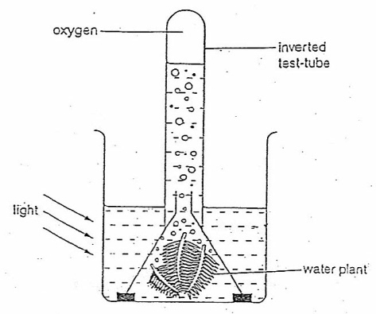
- Set up the apparatus as shown in the diagram. Make sure that the test tube is completely full of water.
- Vary the light intensity by changing the distance of light from the plant.
- Count the number of bubbles produced per minute or the volume of gas (oxygen) collected after 10 minutes for each different intensity of light.
Control variables: Type of plant, size of plant, amount of water in the trough, amount of time to collect the volume of gas.
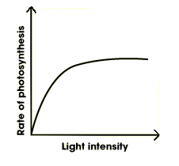
- As light intensity increases, so does the rate of photosynthesis.
- The light intensity (I) is related to the distance (d) between the lamp and the plant (I=1/d²).
- As the lamp is moved closer, the light intensity increases.
- The rate of photosynthesis is directly proportional to the light intensity.
- However the photosynthetic rate cannot be increased indefinitely, a point is reached where all the chloroplasts cannot trap anymore light.

- Describe the intake of carbon dioxide and water by plants.
- Green plants take in carbon dioxide through the stomata in the leaves. This happens by diffusion;
- Behind each stoma is an air space which connects up with other air spaces between the spongy mesophyll cells;
- The cells which need carbon dioxide are the mesophyll cells inside the leaf;
- Carbon dioxide in the air space can then diffuse through the cell wall and cell membrane of mesophyll cells into the chloroplasts.
- Water is absorbed into roots by osmosis and transported to the leaf through xylem vessels;
- It then travels from xylem vessels to the mesophyll cells by osmosis.

- Identify and label the cuticle, cellular and tissue structure of a dicotyledonous leaf, as seen in cross section under the light microscope and describe the significance of the features of a leaf in terms of functions.
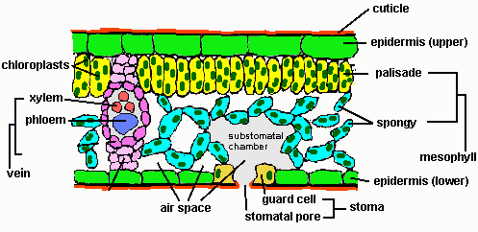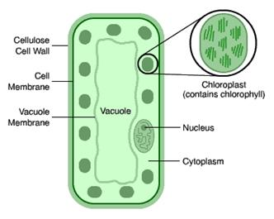
Transverse section through a leaf Palisade cell

Parts of a leaf | Description | Functions
Cuticle | Made of wax, secreted by upper epidermis | Helps in water proofing the leaf to prevent water loss
Upper epidermis | Thin and transparent, absence of chloroplasts | Acts as protective layer & barrier to disease organisms; allows sunlight to penetrate
Palisade mesophyll | No gaps between cells. Cells are long, packed with chloroplasts | Main region for absorption of light for photosynthesis
Spongy mesophyll | Spherical, loosely packed, contain chloroplasts but not as many as palisade | Air spaces between cells allow gaseous exchange - carbon dioxide to the cells, oxygen from the cells during photosynthesis
Vascular bundle | Thin vein made of xylem and phloem | Xylem vessels bring water and minerals to the leaf, phloem vessels transport sugars and amino acids away from the leaf
Lower epidermis | Stomata present | Acts as protective layer,
Stomata | Surrounded by guard cells | Guard cells regulate whether the stoma is open or closed to allow carbon dioxide in & regulate the loss of water vapour during transpiration

- Describe the importance of nitrate and magnesium ions.
- Explain the effects of nitrate ion and magnesium ion deficiency on plant growth.
 | NITROGEN | MAGNESIUM
Mineral salt | Nitrate or ammonium ions | Magnesium ions
Why needed | To make proteins | To make chlorophyll
Deficiency | Slow growth, weak stem, yellow leaves | Yellowing of leaves

- Describe the uses, and the dangers of overuse, of nitrogen-containing fertilizers.
Uses - To increase crop yields
Dangers of overuse – wilting and death of plants, as too much fertilizer results in water being drawn out of the plant roots by osmosis.
Also Eutrophication- this is the destruction of life in nearby rivers and lakes. The process is as follows:
Leaching (nitrates are soluble and carried to the nearby rivers by heavy rainfall)

Rapid algal growth due to extra nitrates

Death of algae (surface algae block light for algae below)

Decay by bacteria (dead algae decomposed by bacteria, bacteria respire and use up oxygen)

Death of aquatic animals due to lack of oxygen

