B7 COORDINATION AND RESPONSE
7.3 TROPIC RESPONSES
1. Define and investigate phototropism and geotropism.
Phototropism - a response in which a plant grows towards or away from the direction from which light is coming
Investigation: IGCSE Biology (Jones & Jones), p. 139, Activity 10.5 ‘To find out how shoots respond to light’.
Geotropism - a response in which a plant grows towards or away from gravity.
Investigation: IGCSE Biology (Jones & Jones), p. 140, Activity 10.6 ‘To find out how roots respond to gravity’.

2. Explain the chemical control of plant growth by auxins including geotropism & phototropism in terms of auxins regulating differential growth.
Control of plant growth by auxins
- Auxins are growth hormones;
- They are produced by the shoot and root tips of growing plants;
- An accumulation of auxin in a shoot stimulates cell growth by the absorption of water;
- However, auxins have the opposite effect in roots, when they build up, they slow down cell growth
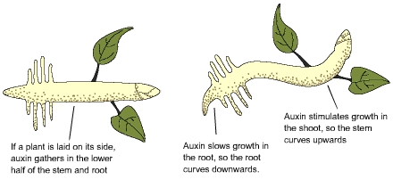
Role of auxins in phototropism and geotropism
Phototropism:
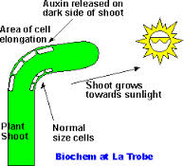
- When a shoot is exposed to light from one side, auxins produced from the shoot tip towards the shaded side of the shoot;
- Cells on shaded side stimulated to absorb more water than those on the light side;
- Thus unequal growth causes the stem to bend towards light;
- This is called positive phototropism.
- If a root is exposed to light in the absence of gravity, auxins produced by the root tip moves towards the shaded side of the root;
- Cells on the shaded side are stimulated to absorb less water than those on the light side;
- Thus unequal growth causes the root to bend away from the light;
- This is called negative phototropism.
Geotropism
- Shoot and roots also respond to gravity;
- If a shoot is placed horizontally in the absence of light, auxins accumulate on the lower side of the shoot, due to gravity;
- This makes the cells on the lower side grow more quickly than on the upper side, so the shoot bends upwards - negative geotropism;
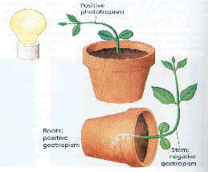

- If a root is placed horizontally in the absence of light, auxins accumulate on the lower side of the root, due to gravity;
- Thus the cells on the lower side grow more slowly than those on the upper side, so the root bends downwards - positive phototropism.

