B9 - INHERITANCE
9.2 - CELL DIVISION

1. Define mitosis
As nuclear division giving rise to genetically identical cells in which the chromosome number is maintained by the exact duplication of chromosomes.

2. State the role of mitosis
- Helps in growth;
- Repairs damaged tissues;
- Replaces worn out cells;
- Asexual reproduction.

3. Define meiosis.
As a reduction in which the chromosome number is halved from diploid to haploid.

4. State that gametes are the result of meiosis.
Gametes are the result of meiosis, which on fertilization helps to retain the chromosome number specific for a species.
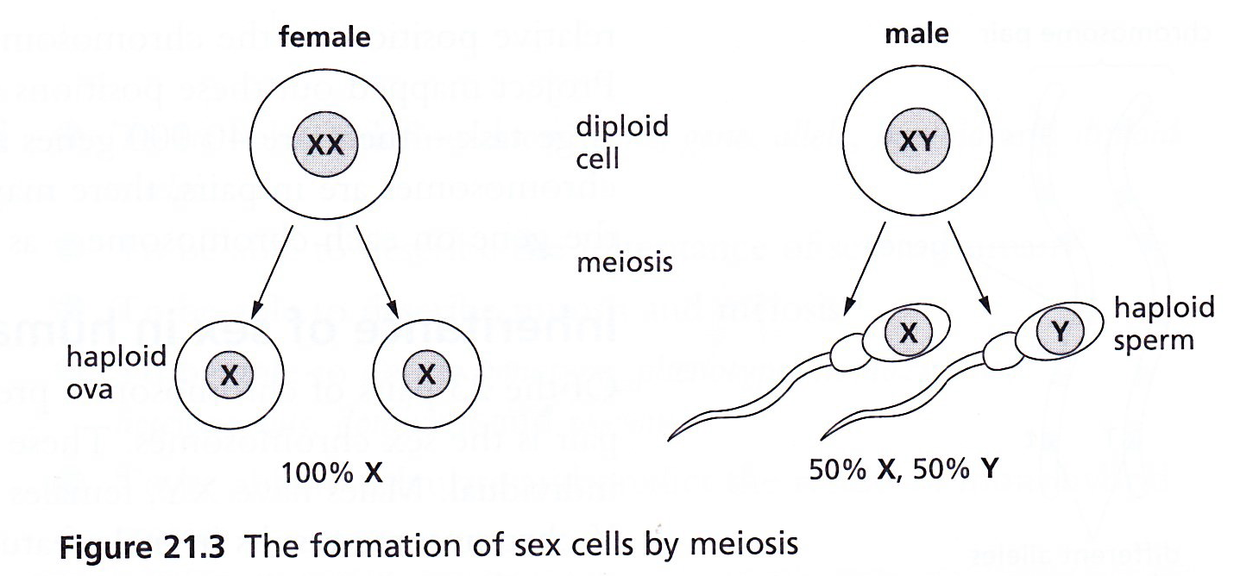

5. State that meiosis results in genetic variation so the cells produced are not all genetically identical.
- Sex cells are formed in the gonads (ovaries and testes) by meiosis;
- The gametes (sex cells) produced are haploid, but they are formed from diploid cells;
- Thus meiosis involves halving the normal chromosome number;
- At the end of the process, cells produced are not all identical, thus meiosis results in variation.

