B2 CELLS
2.1 Cell Structure

- State that living organisms are made of cells.
All living things are made of cells - microscopic units that act as building blocks. Some organisms are unicellular (one-celled), some are multicellular - made up of many cells.

- Identify and describe the structure of a plant cell (palisade cell) and an animal cell (liver cell) as seen under a light microscope.
4. Relate the structures seen under the light microscope in the plant cell and animal cell to their functions.
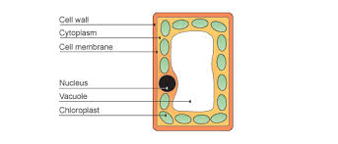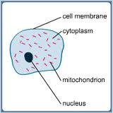
Plant cell (palisade cell) Animal Cell (liver cell)

PARTS OF A CELL

 | PART | DESCRIPTION | FUNCTION
Animal & plant cells | Cytoplasm | Jelly-like, 70% is water | Contains cell organelles  Chemical reactions take place here
 | Membrane | Surrounds the cell; partially permeable | Controls what substances enter & leave the cell.
 | Nucleus | Contains DNA in the form of chromosomes | Controls cell division;  Controls cell development;  Controls cell activities.
Plant cells only | Cell wall | Tough layer made of cellulose, surrounds the cell membrane | Freely permeable (allows water and salts to pass through);  Protects and supports the cell;  Prevents plant cells from bursting
 | Sap vacuole | Fluid-filled space surrounded by a membrane | Contains salts and sugars (cell sap);  Helps keep plant cells turgid (firm)
 | Chloroplast | Organelle containing chlorophyll | Chlorophyll taps light energy for photosynthesis

- Describe the differences in structure between typical animal and plant cells.

PLANT CELLS | ANIMAL CELLS
Have a cellulose cell wall outside the membrane | No cell wall
Often have chloroplasts containing chlorophyll | No chloroplasts
Often have one large vacuoles containing cell sap | Have only small vacuoles (vesicles)
Often have starch grains | Never have starch grains; sometimes have glycogen granules
Often regular in shape | Often irregular in shape

- Relate the structure of the following to their functions: red blood cells (transport), root hair cells (absorption).

Structure | Special features | Functions
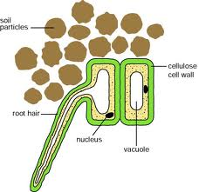 | The ‘hair’ gives a large surface area due to its elongated shape | Absorbs water and mineral ions;  Anchor the plant firmly in the soil
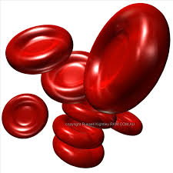 | Have no nucleus;  contain hemoglobin;  biconcave shape (for greater surface area);  flexible (so they fit through small capillaries). | Transport oxygen around the body. No nucleus so more room for oxygen bound to hemoglobin.

- Calculate magnification and size of biological specimens using millimeters as units.

Magnification (X) = Measured length (mm) ÷ Actual length (mm)

2.2 Movement into & out of Cells

- Define Diffusion.
Diffusion is the net movement of molecules from a region of their higher concentration to a region of their lower concentration down a concentration gradient, as a result of their random movement.

- Describe the importance of diffusion of gases and solutes and of water as a solvent.
Factors that help diffusion are as follows:
- Distance (the shorter the better) e.g. thin walls of alveoli and the capillaries.
- Concentration gradient (the bigger the better). This can be maintained by removing the substance as it passes across the diffusion surface.
- Size of the molecules (the smaller the better).
- Surface area for diffusion (the larger the better) e.g. there is millions of alveoli in a lung, giving a huge surface area for diffusion of oxygen.
- Temperature (molecules have more kinetic energy at higher temperatures).

Importance of diffusion of gases and solutes:

Substance diffused | Site of diffusion
Oxygen | From the alveoli into blood capillaries
Carbon dioxide | From blood capillaries into the alveoli.  From air, through stomata & into the leaf for photosynthesis.
Soluble products of digestion | From small intestine to the blood capillaries.
Scent made of tiny molecules | From flowers into the bee’s body.

Importance of water as a solvent:
- Most cells contain about 75% of water;
- Many important metabolic reactions take place in aqueous solution;
- Many substances move around a cell dissolved in water (and also around organisms, e.g. in blood, xylem & phloem).

- Define Osmosis
Osmosis is the diffusion of water molecules from a dilute solution to a more concentrated solution through a partially permeable membrane.

- Describe the importance of osmosis in the uptake of water by plants, and its effect on plant and animal tissues.

Importance of osmosis in the uptake of water by plants:
- Usually, the water in the soil is more dilute than that in root hair cells
- So water enters root hair cells by osmosis (a passive process – requiring no energy)

Effects of osmosis on plant and animal tissues:
- When placed in pure water, plant and animal cells will take in the water by osmosis;
- This is because there is a higher concentration of water molecules outside the cell than inside it;
- Plants become turgid, but do not burst because of their tough cell wall;
- Animal cells will burst, because they have no cell wall;
- The reverse happens when plant and animal cells are placed in a concentrated sugar or salt solutions. This is because there is a higher concentration of water molecules inside the cell than outside it;
- Plant cells become flaccid and the cytoplasm is no longer pressed against the cell wall;
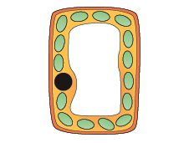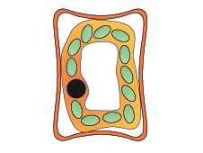
Turgid plant cell Flaccid plant cell

- Animal cells also become flaccid and their shape changes- they can become crenated.

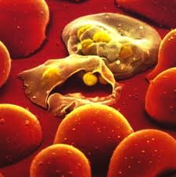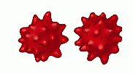
RBC burst Crenated RBC

- Describe and explain the importance of a water potential gradient in the uptake of water by plants.

- Water potential is the correct term for saying ”water concentration” a high water potential is equivalent to a low solute concentration and vice versa;
- For plants to take in water through their roots they must have a high solute concentration or low water potential in the roots and low solute concentration or high water potential outside the roots.
- In osmosis, water molecules diffuse down a water potential gradient.

