B2 CELLS
2.1 Cell Structure

- State that living organisms are made of cells.
All living things are made of cells - microscopic units that act as building blocks. Some organisms are unicellular (one-celled), some are multicellular - made up of many cells.

- Identify and describe the structure of a plant cell (palisade cell) and an animal cell (liver cell) as seen under a light microscope.
4. Relate the structures seen under the light microscope in the plant cell and animal cell to their functions.
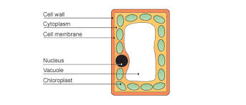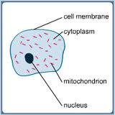
Plant cell (palisade cell) Animal Cell (liver cell)

PARTS OF A CELL

 | PART | DESCRIPTION | FUNCTION
Animal & plant cells | Cytoplasm | Jelly-like, 70% is water | Contains cell organelles  Chemical reactions take place here
 | Membrane | Surrounds the cell; partially permeable | Controls what substances enter & leave the cell.
 | Nucleus | Contains DNA in the form of chromosomes | Controls cell division;  Controls cell development;  Controls cell activities.
Plant cells only | Cell wall | Tough layer made of cellulose, surrounds the cell membrane | Freely permeable (allows water and salts to pass through);  Protects and supports the cell;  Prevents plant cells from bursting
 | Sap vacuole | Fluid-filled space surrounded by a membrane | Contains salts and sugars (cell sap);  Helps keep plant cells turgid (firm)
 | Chloroplast | Organelle containing chlorophyll | Chlorophyll taps light energy for photosynthesis

- Describe the differences in structure between typical animal and plant cells.

PLANT CELLS | ANIMAL CELLS
Have a cellulose cell wall outside the membrane | No cell wall
Often have chloroplasts containing chlorophyll | No chloroplasts
Often have one large vacuoles containing cell sap | Have only small vacuoles (vesicles)
Often have starch grains | Never have starch grains; sometimes have glycogen granules
Often regular in shape | Often irregular in shape

- Relate the structure of the following to their functions: red blood cells (transport), root hair cells (absorption).

Structure | Special features | Functions
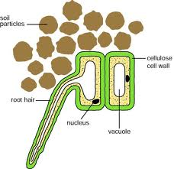 | The ‘hair’ gives a large surface area due to its elongated shape | Absorbs water and mineral ions;  Anchor the plant firmly in the soil
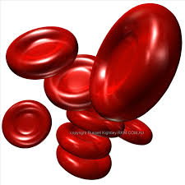 | Have no nucleus;  contain hemoglobin;  biconcave shape (for greater surface area);  flexible (so they fit through small capillaries). | Transport oxygen around the body. No nucleus so more room for oxygen bound to hemoglobin.

- Calculate magnification and size of biological specimens using millimeters as units.

Magnification (X) = Measured length (mm) ÷ Actual length (mm)

