B3 - ENZYMES

- Define enzymes - proteins that function as biological catalysts – they speed up chemical reactions but are themselves unchanged. Their action relies on their shape, as their substrate molecule (s) fit into their active site as in the lock & key hypothesis:
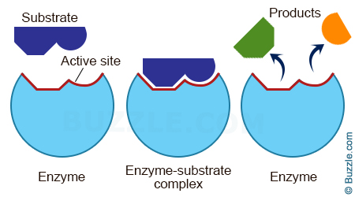

- Investigate and describe the effect of changes in temperature and pH on enzyme activity.
- Explain the effect of changes in temperature and pH on enzyme activity.

Effect of temperature on enzymes
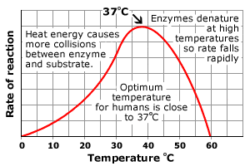
- As temperature increases, the chance of chance of substrate molecules and enzymes colliding also increases, so the rate of reaction goes up.
- This continues to an optimum (best) temperature for an enzyme. For most human enzymes the optimum temperature is 37ºC (body temperature).
- Above this temperature, the bonds holding the enzyme together start to break so it changes shape
- This deforms the active site, so enzyme and substrate cannot fit together – the enzyme has been denatured. Most enzymes denature above 50ºC.

Effect of pH on enzymes

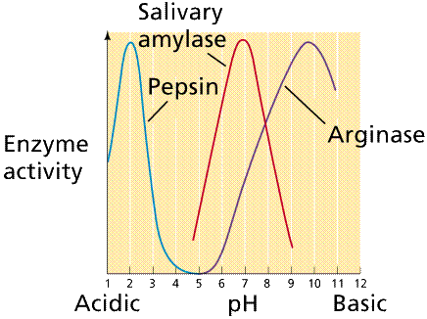

- The pH of a solution is how acidic or alkaline it is.
- Most human enzymes have an optimum pH of 7 (neutral). Some exceptions:
Pepsin, a protease in the stomach has an acidic optimum (pH2);
Lipase in the duodenum has an alkaline optimum (pH 9)
Salivary amylase in the mouth prefers a slightly-acidic pH of 6.8.
- Extreme of pH affect the shape of enzymes, denaturing them.

