B4 – NUTRITION
4.3 Animal Nutrition

- State the term balanced diet & describe how balanced diet is related to age, sex & activity of an individual.
Balanced diet: A diet that contains all the main nutrients (carbohydrate, fats, protein, vitamins, minerals, fibre & water) in the correct amounts and proportions.
- Dietary requirements depend on your age, sex and activity;
- The amount of energy needed is provided by our carbohydrate and fat intake;
- Generally, males use more energy than females;
- And generally the energy demand increases as we get older until we stop growing;
- Someone doing physical work will use up more energy than an office worker;
- While children are growing they need more protein per kilogram of body weight than adults do;
- Pregnant women need extra nutrients for the development of the fetus.

- Describe the effects of malnutrition in relation to starvation, coronary heart disease, constipation and obesity.

Disease | Cause of malnutrition | Symptoms and consequences
Obesity | Too much food | Heart disease, strokes, diabetes
Coronary heart disease | Too much saturated fat (causes high cholesterol levels in the blood) | Cholesterol sticks to the walls of coronary arteries, so not enough blood can get to the heart, leads to heart attack
Starvation  (e.g. in anorexia nervosa) | Too little food (e.g. intense fear of gaining weight) | Weight loss, organ damage, death  (depression, loneliness, insecurity)
Constipation | Lack of fibre | Unable to defecate, pain

- Define ingestion. Taking substances (e. g. food and drink) into the body through the mouth.

- Define egestion. Passing out of food that has not been digested, as faeces, through the anus.

- Identify the main regions of the alimentary canal and the associated organs including mouth, salivary glands, oesophagus, stomach, small intestine: duodenum and ileum, pancreas, liver, gall bladder, large intestine: colon and rectum , anus.
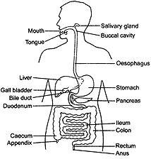
- Describe the functions of the regions of the alimentary canal listed above, in relation to ingestion, digestion, absorption, assimilation and egestion of food.

Region | Functions
Mouth | Food is ingested here; mechanical digestion by cutting, chewing and grinding of teeth; Saliva added - contains amylase to digest starch.
Oesophagus | Boluses of food pass through by peristalsis, from mouth to stomach.
Stomach | Gastric juice added- contains protease to digest protein and hydrochloric acid to maintain pH 2 and kill bacteria.
Duodenum | Receives pancreatic juice containing protease, lipase and amylase. Juice also contains sodium hydrogen carbonate which neutralizes acid from the stomach - giving pH of 8.
Pancreas | Secretes pancreatic juice into the duodenum.
Liver | Makes bile, which is stored in gall bladder; bile contains salts that emulsify fats; digested food is assimilated here, e.g. glucose is stored as glycogen.
Ileum | Epithelial lining secretes enzymes which breakdown maltose and peptides; contains villi which increase the surface area for absorption of digested food.
Colon | Main function is reabsorption of water from undigested food
Rectum | Stores faeces until it is egested
Anus | This has sphincter muscles to control when faeces is egested from the body

- Define digestion. Digestion is the breakdown of large, insoluble food molecules into small, water- soluble molecules using mechanical and chemical processes.

- Identify the types of human teeth and describe their structure and functions
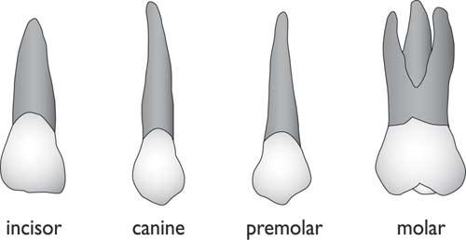

Type of teeth | Structure | Function
Incisor (4 in each jaw) | Chisel-shaped(sharp edge) | Biting off pieces of food
Canine (2 in each jaw) | Slightly more pointed than incisors | Similar function to incisors and also helps in tearing flesh in carnivores
Premolar (4 in each jaw) | Have 2 pointed cusps; have 1-2 roots | Chewing and Grinding food
Molar (6 in each jaw) | Have 4-5 cusps; have 2-3 roots. | Chewing and Grinding food

Section through a molar tooth | Description
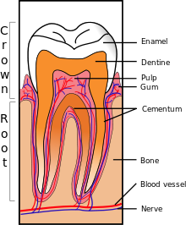 | - Part embedded in the gum called root.  - Part which can be seen is called crown covered with enamel.  - Enamel hardest substance made by animals but can be dissolved by acids.  - Under enamel is dentine which contains living cytoplasm; dentine is hard.  - Middle of the tooth is pulp cavity containing nerve and blood vessels which supply dentine with food and oxygen.  - Root is covered with cement; it has fibres growing out of it which attach the tooth to the jawbone, but allow slight movement when biting or chewing.

- State the causes of dental decay and describe the proper care of teeth.
- Bacteria are present on the surface of our teeth;
- Food deposits and bacteria form a layer called plaque;
- Bacteria in the plaque may infect the gums causing gum disease;
- Bacteria in the plaque feed on sugars in the food, producing acid;
- This acid dissolves enamel, forming a hole;
- Dentine underneath the enamel is softer and dissolves more rapidly;
- If the hole reaches the pulp cavity, bacterial infection can get to the nerve;
- This results in toothache and possibly an abscess (an infection in the jaw).

Tooth decay and gum disease can be prevented
- Avoid sugary food, especially between meals, so bacteria cannot make acid
- Clean teeth regularly to remove plaque (a fluoride toothpaste hardens tooth enamel);
- Use dental floss or a toothpick to remove pieces of food and plaque trapped between teeth;
- Visit a dentist regularly so any tooth decay is treated early and any stubborn plaque is removed.

- State the significance of chemical digestion in the alimentary canal in producing small, soluble molecules that can be absorbed.
- Chemical digestion involves breaking down large, insoluble molecules into small, soluble ones;
- Enzymes speed up the process;
- Enzymes work efficiently at body temperature (37⁰C) and at a suitable pH;
- Small, water soluble molecules of food is easily absorbed into the blood capillaries in the intestine.

- State where in the alimentary canal, amylase, protease and lipase enzymes are secreted.
- State the functions of a typical amylase, protease and lipase, listing the substrate and end-products.

Enzyme | Site of action | Special conditions | Substrate | End products
Amylase | Mouth, duodenum | Slightly alkaline | Starch | Maltose, glucose
Protease | Stomach,  duodenum | Acid in stomach, alkaline in duodenum | Protein | Amino acids
Lipase | Duodenum | alkaline | fat | Fatty acids and glycerol

- Outline the role of bile in emulsifying fats, to increase the surface area for the action of enzymes.
- Bile is made in the liver, stored in gall bladder and then flows along bile duct into duodenum;
- Bile does not contain any enzymes;
- Bile helps to digest fat by breaking the large drops of fat into very small ones;
- This makes it easier for lipase to digest them;
- This is called emulsification (a kind of mechanical digestion) and is done by bile salts.

- Define absorption
Absorption is movement of digested food molecules through the wall of the intestine into the blood.

- Describe the significance of villi in increasing the internal surface area of the small intestine.
- Villi are finger-like projections that increase the surface area for absorption of small molecules.
- The larger the surface area, the faster nutrients can be absorbed.
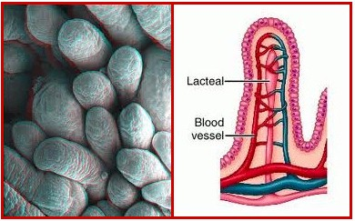

STRUCTURE & FUNCTION OF VILLI

FEATURE | FUNCTION
Each villus is covered with cells which have even smaller projections on them called microvilli | This gives inner surface of the small intestine a very large surface area – nutrients can be absorbed even faster.
Villi have walls only one cell thick | Nutrients can diffuse across the wall to reach the blood capillaries and lacteals faster.
Villi contain blood capillaries | Absorbs small molecules such as amino acids and glucose
Villi contain lacteals, which are part of the lymphatic system | Absorbs fatty acids and glycerol

- Identify the small intestine as the region for the absorption of digested.
- Describe the structure of a villus, including the role of capillaries and lacteals
See above.

- Describe the role of liver in the metabolism of glucose.
- If there is more glucose than necessary in the blood, the liver will convert some of it to the polysaccharide called glycogen and store it.

- Describe the role of fat as an energy storage substance.
- Fat may be used in respiration as a source of energy, or stored;
- Fatty acids & glycerol are absorbed by the lacteal in the villi;
- They are carried in the bloodstream to body cells;
- Here the fat molecules are reformed;
- Fat is a good storage compound as when respired, it releases twice as much energy as carbohydrates.

