B6 - RESPIRATION
6.2 Gas Exchange

- Identify on diagrams and name the larynx, trachea, bronchi, bronchioles, alveoli and associated capillaries.
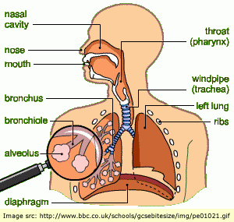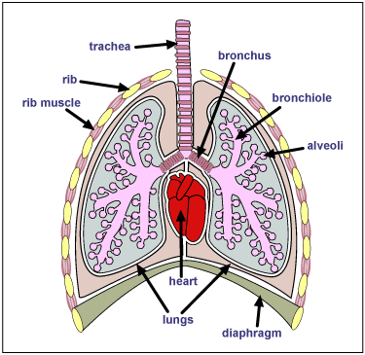

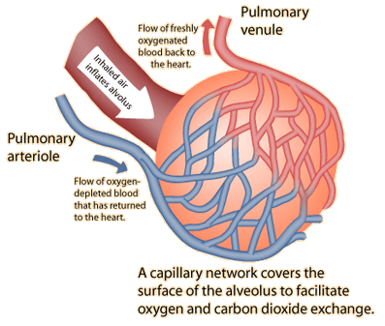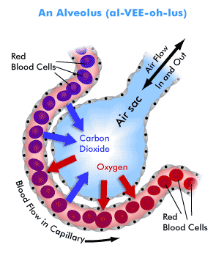
- List the features of gas exchange surfaces in animals.
- Wall of the alveolus is thin (a single layer of cells) to allow gases to diffuse across them quickly;
- They are moist to prevent the cells from drying and to allow gases to dissolve;
- They have a large surface area , so that a lot of gas can diffuse across at the same time;
- They have a high concentration gradient - maintained by the movement of air & blood.

- Explain the role of mucus and cilia in protecting the gas exchange system from pathogens and particles.
Air
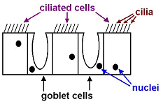Diagram of lining of trachea

- The lining contains two kinds of cells: Goblet cells and ciliated cells;
- Goblet cells make sticky, slimy mucus;
- Many of the bacteria in the air and dust particles get trapped in the mucus;
- Ciliated cells have tiny, microscopic hair on them called cilia;
- The cilia beat in unison, and sweep the mucus upwards, towards the back of the throat.

- Describe the effects of tobacco smoke and its major toxic components (tar, nicotine, carbon monoxide, smoke particles) on the gas exchange system.

Chemical | Effects on gas exchange system
Carbon monoxide | A poisonous gas; combines with hemoglobin in RBC, preventing them from transporting oxygen
Nicotine | Addictive; increases heart rate & blood pressure
Smoke particles | Irritate the air passages, causing inflammation & increased mucus production, resulting in chronic bronchitis; coughing and the presence of particles in the alveoli can lead to emphysema (breaking the walls of the alveoli)
Tar | A carcinogen - increases the risk of lung cancer; lines the air passages, increasing mucus production and paralyzing and damaging cilia, causing bronchitis.

- State the differences in composition between inspired and expired air.

Gas | Inspired air % | Expired air % | Explanation
Nitrogen | 79 | 79 | Not used or produced by body processes
Oxygen | 21 | 16 | Used up in the process of respiration
Carbon dioxide | 0.04 | 4 | Produced in the process of respiration
Water vapour | Variable | Saturated | Produced in the process of respiration, moisture evaporates from the surface of the alveoli

- Use lime water as a test for carbon dioxide to investigate the differences in composition between inspired and expired air.
IGCSE Biology (Jones & Jones), p. 122, activity 9.5 ‘comparing the CO₂ content of inspired & expired air’.

- Investigate and describe the effects of physical activity on rate and depth of breathing.
- Explain the effects of physical activity on the rate and depth of breathing.

- The volume of air breathed in and out during normal, relaxed breathing is about 0.5 litres (the tidal volume);
- The breathing rate is about 12 breaths per minute;
- During exercise, the volume inhaled (depth) increases to about 5 litres ( depending on the age, sex, size and fitness of the person);
- The maximum amount of air breathed in and out in one breath is the vital capacity;
- The breathing rate can increase to over 20 breaths per minute;
- The total lung volume is greater than the vital capacity because some air always remains in the lungs (otherwise the lungs would collapse and the alveoli walls would stick together)
- Breathing rate and depth increase to absorb more oxygen for the muscles as exercising muscles need to respire more to get more energy.

