B7 COORDINATION AND RESPONSE
7.1 - NERVOUS CONTROL IN HUMANS

1. Describe the human nervous system in terms of the central nervous system (brain & spinal cord as areas of coordination) & the peripheral nervous system, which together serve to coordinate & regulate body functions.
- The human nervous system is made of two parts-central nervous system (CNS) and peripheral nervous system(PNS);
- CNS - brain and spinal cord, which have the role of coordination;
- PNS - nerves, which connect all parts of the body to the CNS;
- Sense organs are linked to the PNS; they contain groups of receptor cells;
- When exposed to a stimulus they generate an electrical impulse, which passes along peripheral nerves to the CNS, triggering a response.
- Peripheral nerves contain sensory and motor neurons;
- Sensory neurons transmit nerve impulses from sense organs to the central nervous system;
- Motor neurons transmit nerve impulses from the CNS to effectors (muscles or glands)
- Neurons are covered with a myelin sheath, which insulates them to make transmission of the impulse more efficient;
- Relay neurons pick up messages from other neurons and pass them on to other neurons.
- The cytoplasm (mainly axon and dendron) is elongated to transmit the impulse for long distances.
COMPARISON OF MOTOR AND SENSORY NEURON
Structure | Sensory neuron | Motor neuron
1.Cell body | Near end of the neuron, just outside the spinal cord | At start of neuron, inside the spinal cord
2.Dendrites | Present at the end of neuron | Attached to cell body and inside the spinal cord
3. Axon (takes impulses away from cell body) | Very short stretch into spinal cord | Very long, stretches from spinal cord into a muscle
4. Dendron | Very long stretches to a receptor | None
3. Identify motor (effector), relay (connector) and sensory neurons from diagrams.
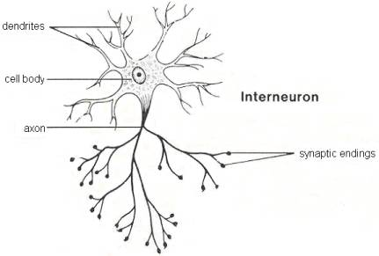
Relay neuron
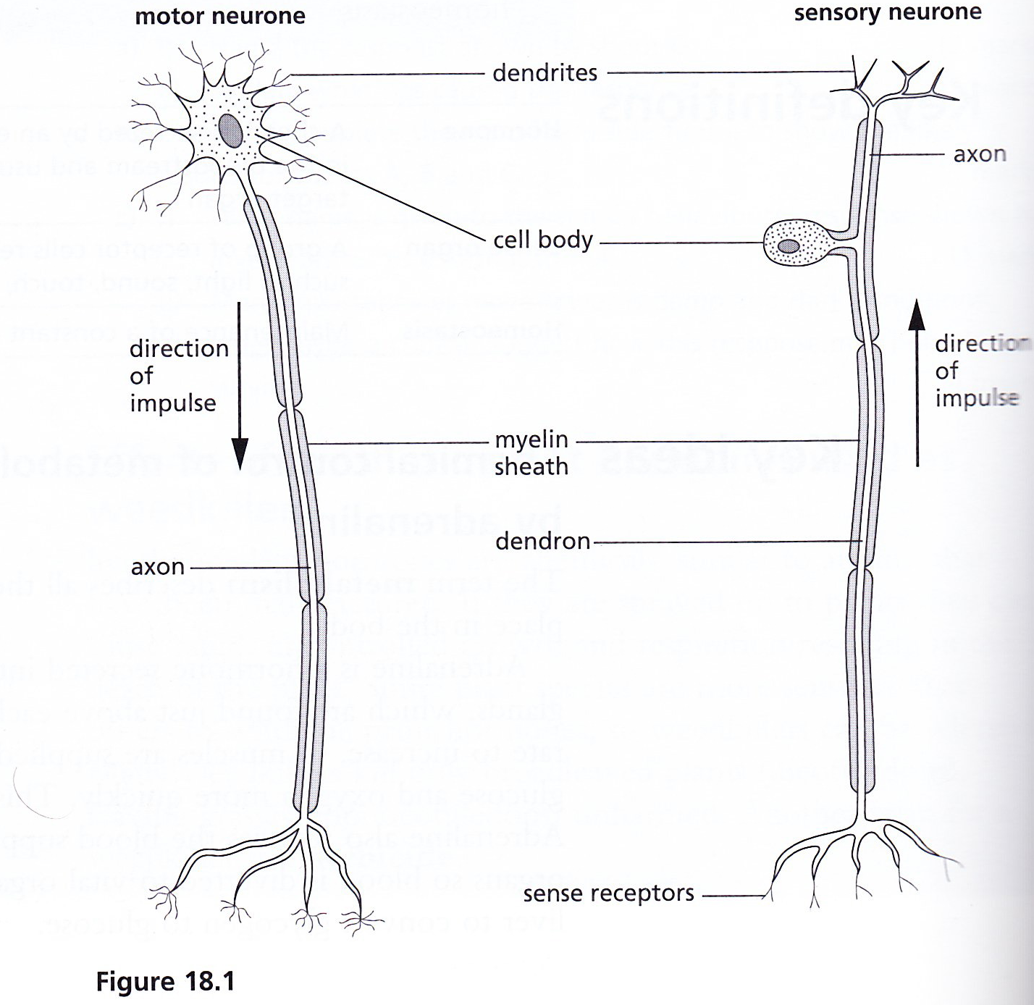
4. Describe a simple reflex arc in terms of sensory, relay and motor neurons and a reflex action as a means of automatically and rapidly integrating and coordinating stimuli with responses.
- A reflex action is a fast, automatic response to a stimulus;

REFLEX ARC
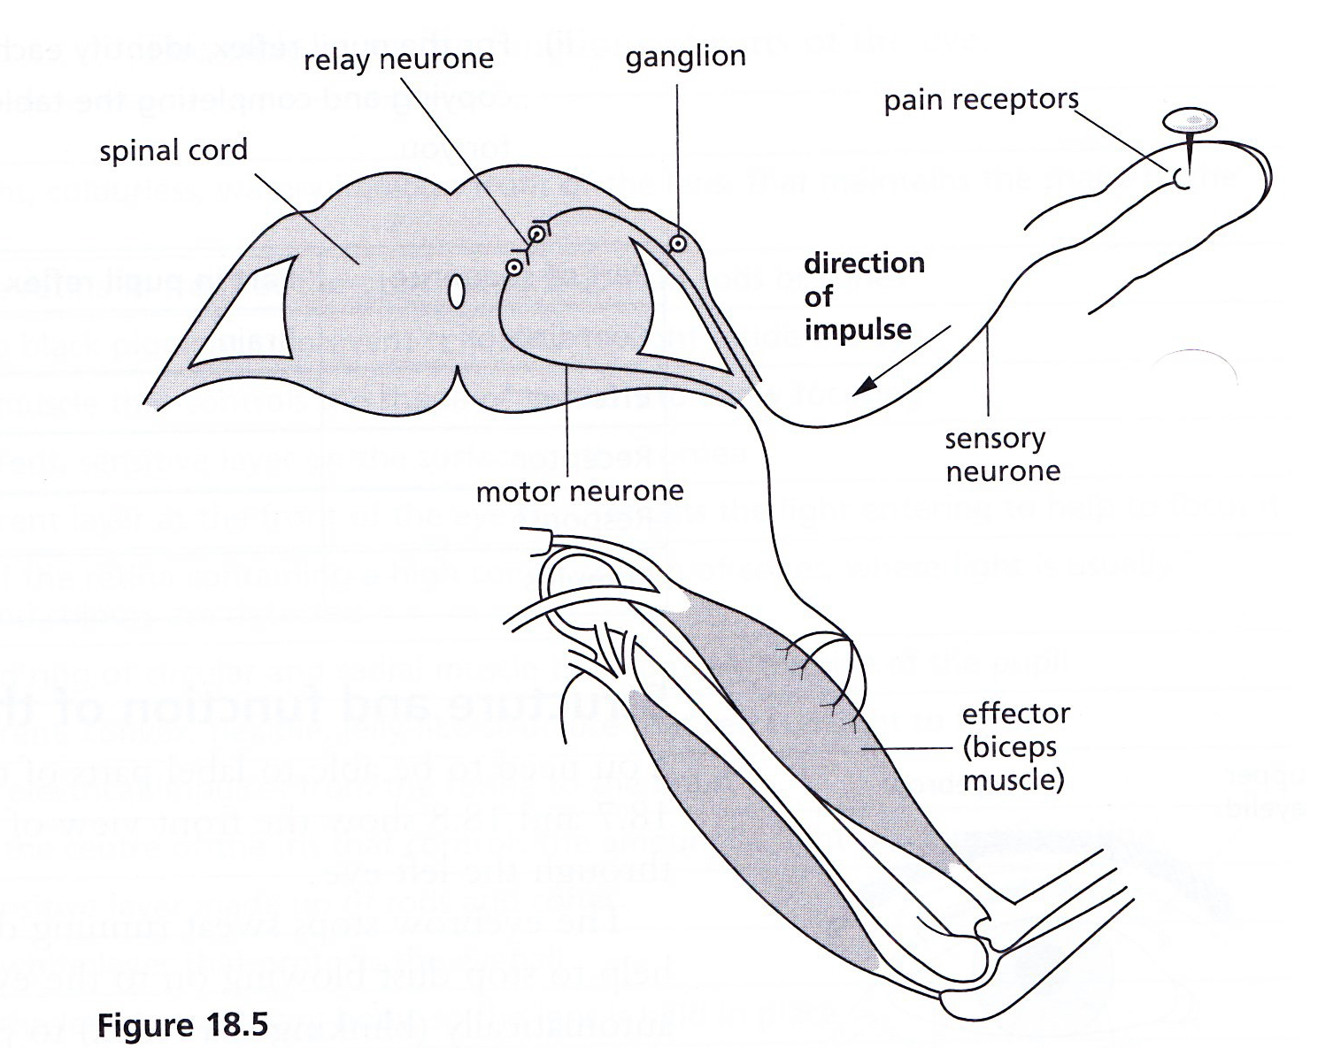
- A reflex arc describes the pathway of an electrical impulse in response to a stimulus;
- In diagram above, the stimulus is a pin sticking in the finger;
- The response is the withdrawal of the arm due to contraction of the biceps;
- Relay neurons are found in the spinal cord, connecting sensory neurons to motor neurons;
- Neurons do not connect directly with each other: there is a gap called a synapse.
- The sequence of events is
Stimulus (sharp pin in finger)

Receptor (pain receptors in skin)

Coordinator (spinal cord)

Effector (biceps muscle)

Response (biceps muscle contracts, hand is withdrawn from pin
2. Describe the structure and function of the eye, including accommodation and pupil reflex.
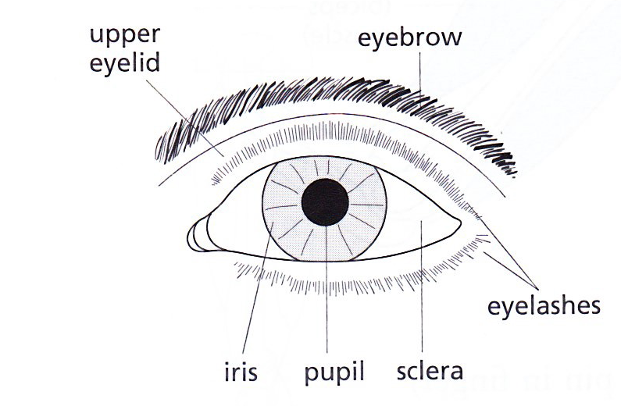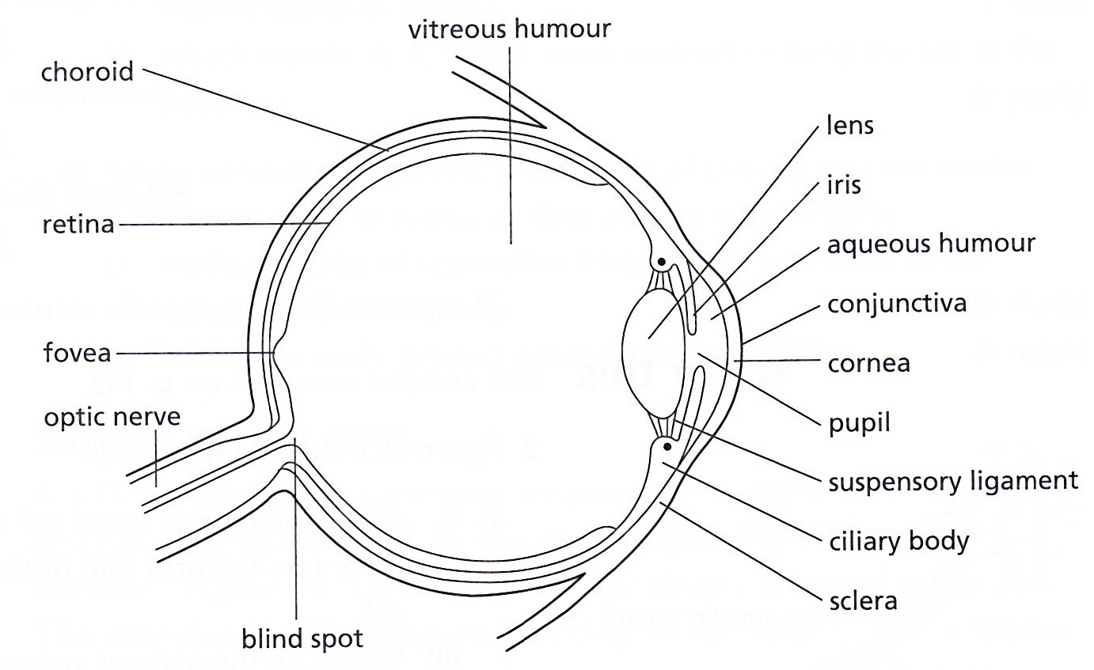
Front view Section through the eye

Part of the eye | Function
Fovea | An area of the retina containing a high concentration of cones, where light is usually focused and colours are detected
Blind spot | Part of the retina in front of the optic nerve that lacks rods or cones
Optic nerve | Transmits electrical impulses from the retina to the brain
Conjunctiva | A transparent, sensitive layer on the surface of the cornea
Sclera | A tough, white layer that protects the eyeball
Choroid | Produces a black pigment to prevent reflection of light inside the eye
Retina | A light sensitive layer made of rods and cones
Ciliary body | A ring of muscle that controls the shape of the lens to allow focusing
Suspensory ligament | Attaches the lens to the ciliary body, so the lens is held in place
Cornea | A transparent layer at the front of the eye that refracts the light entering to help to focus it
Iris | A coloured ring of circular and radial muscle that controls the size of the pupil
Lens | A transparent, convex, flexible, jelly-like structure that refracts light to focus it
Pupil | A hole in the centre of the iris that controls the amount of light reaching the retina
Rods | Sensitive to dim light, do not respond to colour
Cones | Function when the light is bright, able to distinguish between different colours of light

PUPIL (or iris) REFLEX (an e.g. of reflex action)
- This reflex action changes the size of the pupil to control the amount of light entering the eye
- In bright light:
- Retina detects the brightness of light entering the eye;
- An impulse passes to the brain along sensory neurons and travels back to the muscles of the iris along motor neurons, triggering a response:
- Circular muscles contract; radial muscles relax; so iris gets bigger
- Pupil constricts (gets smaller) so less light falls on the retina (to prevent damage).

- In dim light:
- Retina detects the brightness of light entering the eye;
- An impulse passes to the brain along sensory neurons and travels back to the muscles of the iris along motor neurons, triggering a response:
- Radial muscles contract; circular muscles relax; so iris gets smaller
- Pupil size is increased (dilated) to allow as much light as possible to enter the eye;

ACCOMMODATION
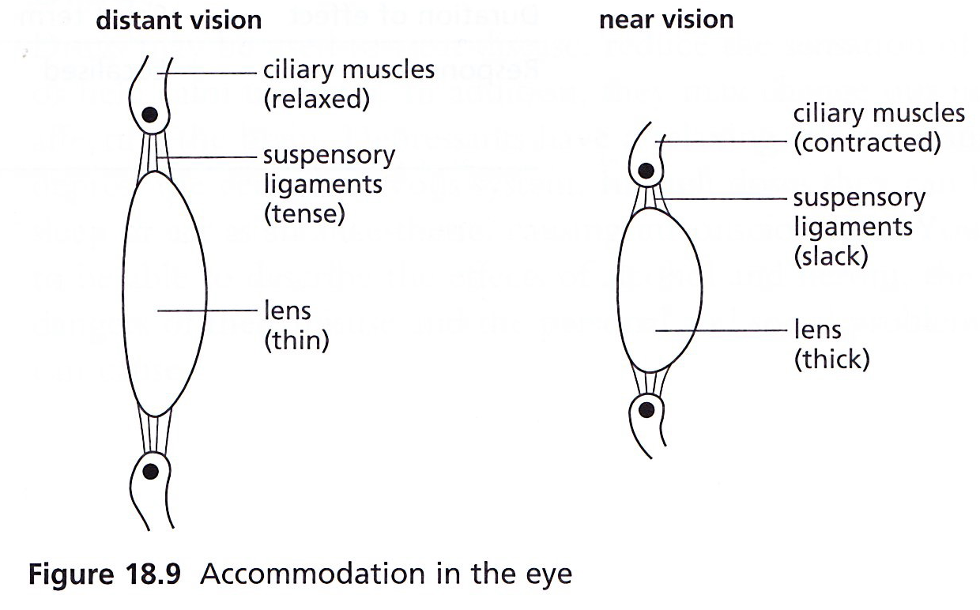
To focus on a distant object | To focus on a nearby object
Slightly diverging rays of light enter the eye | Greatly diverging rays enter the eye
Ciliary muscles relax | Ciliary muscles contract
Suspensory ligaments are pulled tight | Suspensory ligaments slacken (loosen)
Lens becomes thin | Lens get fatter
The thin lens bends the light rays slightly | The thick lens bends the light rays greatly

7.2 - HORMONES
1. Define a hormone
A chemical substance, produced by a gland, carried by the blood, which alters the activity of one or more specific target organs and is then destroyed by the liver.

2. State the role of the hormone adrenaline in the chemical control of metabolic activity, including increasing the blood glucose concentration and pulse rate.
- Adrenaline is secreted by adrenal glands located one above each kidney;
- Adrenaline helps us to cope with danger by increasing the heart rate;
- Thus supplying oxygen to brain and muscles more quickly, this increase the rate of metabolic activity and gives more energy for fighting or running away;
- The blood vessels in skin and digestive system contract so that they carry very little blood, as a result we get ‘butterflies in our stomach’, and more blood goes to brain and muscles;
- Adrenaline also causes the liver to release glucose into the blood;
- This provides extra glucose to the muscles, thus more respiration and more energy is released for contraction.

3. Give examples of situations in which adrenaline secretion increases.
- Examination;
- Visit to a dentist.

4. Compare nervous and hormonal control systems.
Feature | Nervous | Hormonal (endocrine)
What are they made of | Neurons | Secretory cells
Form of transmission | Electrical impulses | Chemical (hormones)
Transmission pathway | Nerves | Blood vessels
Speed of transmission | Fast | Slow
Duration of effect | Short term | Long term
Response | Localized | Widespread (although there may be a specific target organ)

7.3 TROPIC RESPONSES
1. Define and investigate phototropism and geotropism.
Phototropism - a response in which a plant grows towards or away from the direction from which light is coming
Investigation: IGCSE Biology (Jones & Jones), p. 139, Activity 10.5 ‘To find out how shoots respond to light’.
Geotropism - a response in which a plant grows towards or away from gravity.
Investigation: IGCSE Biology (Jones & Jones), p. 140, Activity 10.6 ‘To find out how roots respond to gravity’.

2. Explain the chemical control of plant growth by auxins including geotropism & phototropism in terms of auxins regulating differential growth.
Control of plant growth by auxins
- Auxins are growth hormones;
- They are produced by the shoot and root tips of growing plants;
- An accumulation of auxin in a shoot stimulates cell growth by the absorption of water;
- However, auxins have the opposite effect in roots, when they build up, they slow down cell growth
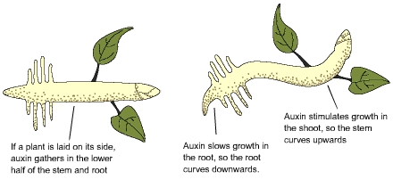
Role of auxins in phototropism and geotropism
Phototropism:
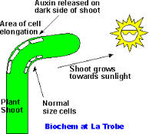
- When a shoot is exposed to light from one side, auxins produced from the shoot tip towards the shaded side of the shoot;
- Cells on shaded side stimulated to absorb more water than those on the light side;
- Thus unequal growth causes the stem to bend towards light;
- This is called positive phototropism.
- If a root is exposed to light in the absence of gravity, auxins produced by the root tip moves towards the shaded side of the root;
- Cells on the shaded side are stimulated to absorb less water than those on the light side;
- Thus unequal growth causes the root to bend away from the light;
- This is called negative phototropism.
Geotropism
- Shoot and roots also respond to gravity;
- If a shoot is placed horizontally in the absence of light, auxins accumulate on the lower side of the shoot, due to gravity;
- This makes the cells on the lower side grow more quickly than on the upper side, so the shoot bends upwards - negative geotropism;
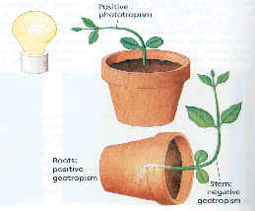

- If a root is placed horizontally in the absence of light, auxins accumulate on the lower side of the root, due to gravity;
- Thus the cells on the lower side grow more slowly than those on the upper side, so the root bends downwards - positive phototropism.

7.4 - HOMEOSTASIS
1. Define homeostasis
The maintenance of a constant internal environment.
2. Identify, on a diagram of the skin: hairs, sweat glands, temperature receptors, blood vessels and fatty tissue.
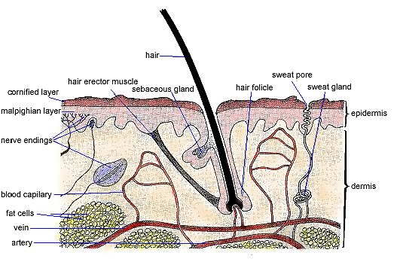
3. Describe the maintenance of a constant body temperature in humans in terms of insulation and the role of temperature receptors in the skin, sweating, shivering, vasodilation and vasoconstriction of arterioles supplying skin-surface capillaries and the coordinating role of the brain.
- Humans maintain a body temperature of 37ºC;
- A part of the brain called the hypothalamus keeps internal temperature constant by acting like a thermostat;
- If the temperature is above or below 37ºC, the hypothalamus receives information from thermo receptors in our skin and sends electrical impulses, along nerves, to the parts of the body which have the function of regulating our body temperature.
- When cold, the body produces and saves heat in the following ways:
- Shivering: Muscles in some parts of the body contract and relax very quickly. This produces heat and is called shivering.
- Metabolism may increase;
- Hair stands up: This produces ‘goose flesh’ and traps a thicker layer of warm air next to the skin, acting as an insulator;
- Vasoconstriction: The arterioles that supply the skin blood capillaries becomes narrower, thus less blood flows in them and thus less heat is lost to the air by radiation. 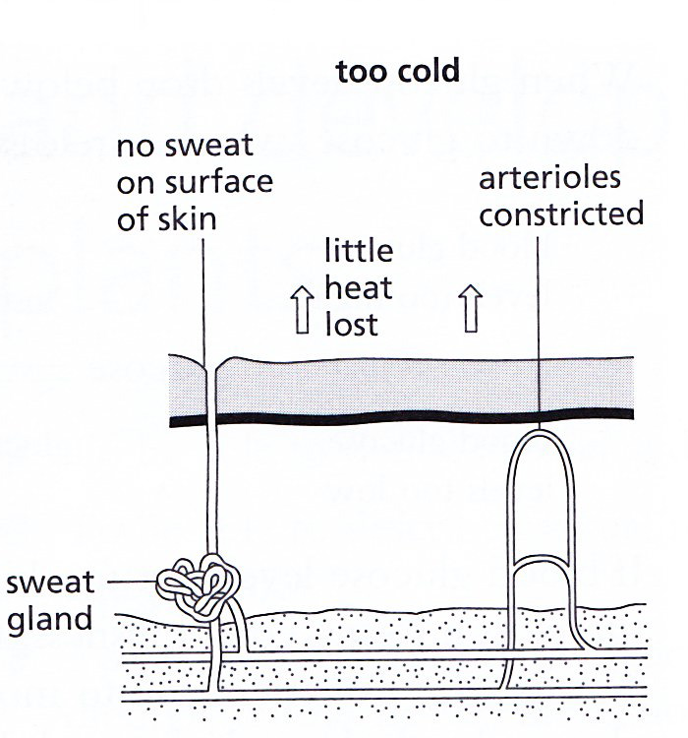

> When hot, the body loses more heat in the following ways:
a. Hair lies flat: No insulation
- Vasodilation: The arterioles that supply the skin blood capillaries gets dilated, thus more blood flows through them and thus heat is readily lost from the blood into the air by radiation;
- Sweating: Sweat gland secretes sweat on the surface of skin, which evaporates, taking heat from the skin with it, thus cooling the body;
- Metabolism slows down.
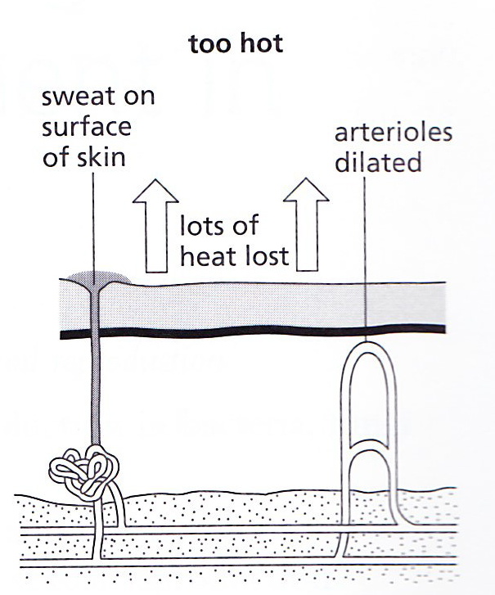
4. Explain the concept of control by negative feedback.
- A change from normal, for instance an increase in blood glucose levels , triggers a sensor, which stimulates a response in an effector;
- However, the response in this case is the secretion of insulin hormone, which would eventually result in glucose levels dropping below normal;
- As glucose levels drop, the sensor detects the drop and instructs the effector (pancreas) to stop secreting insulin (negative effect);
- This is negative feedback- the change is fed back to the effector.
5. Describe the control of the glucose content of the blood by the liver, and by insulin and glucagon from the pancreas.
- Liver is a homeostatic organ, it controls the levels of glucose;
- Two hormones – insulin and glucagon control blood glucose levels;
- Both hormones are secreted by pancreas and are transported to the liver in the bloodstream.

Role of insulin in controlling blood glucose levels:
- When blood glucose levels are high, then insulin is secreted by pancreas;
- Insulin passes in the bloodstream and then to the liver;
- Insulin stimulates the liver to absorb glucose;
- Insulin converts glucose to glycogen;
- Insulin also increases the rate of respiration; so more blood glucose is absorbed by cells and used up, to reduce blood glucose levels.

Role of glucagon in controlling blood glucose levels:
- When blood glucose levels drop below normal, glucagon is secreted by the pancreas;
- Glucagon passes in the bloodstream and then to the liver;
- Glucagon converts glycogen to glucose in the liver;
- Glucose is then released into the bloodstream.

