B7 COORDINATION AND RESPONSE
7.1 - NERVOUS CONTROL IN HUMANS

1. Describe the human nervous system in terms of the central nervous system (brain & spinal cord as areas of coordination) & the peripheral nervous system, which together serve to coordinate & regulate body functions.
- The human nervous system is made of two parts-central nervous system (CNS) and peripheral nervous system(PNS);
- CNS - brain and spinal cord, which have the role of coordination;
- PNS - nerves, which connect all parts of the body to the CNS;
- Sense organs are linked to the PNS; they contain groups of receptor cells;
- When exposed to a stimulus they generate an electrical impulse, which passes along peripheral nerves to the CNS, triggering a response.
- Peripheral nerves contain sensory and motor neurons;
- Sensory neurons transmit nerve impulses from sense organs to the central nervous system;
- Motor neurons transmit nerve impulses from the CNS to effectors (muscles or glands)
- Neurons are covered with a myelin sheath, which insulates them to make transmission of the impulse more efficient;
- Relay neurons pick up messages from other neurons and pass them on to other neurons.
- The cytoplasm (mainly axon and dendron) is elongated to transmit the impulse for long distances.
COMPARISON OF MOTOR AND SENSORY NEURON
Structure | Sensory neuron | Motor neuron
1.Cell body | Near end of the neuron, just outside the spinal cord | At start of neuron, inside the spinal cord
2.Dendrites | Present at the end of neuron | Attached to cell body and inside the spinal cord
3. Axon (takes impulses away from cell body) | Very short stretch into spinal cord | Very long, stretches from spinal cord into a muscle
4. Dendron | Very long stretches to a receptor | None
3. Identify motor (effector), relay (connector) and sensory neurons from diagrams.
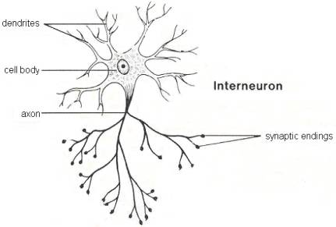
Relay neuron
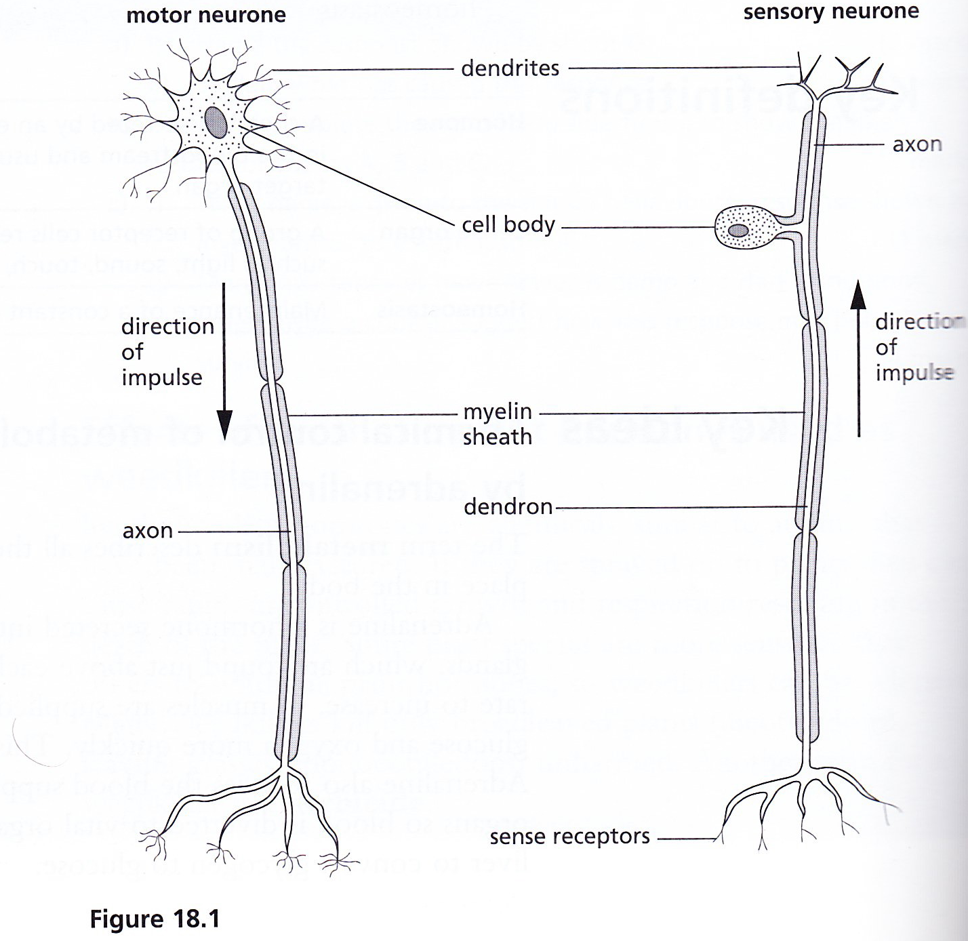
4. Describe a simple reflex arc in terms of sensory, relay and motor neurons and a reflex action as a means of automatically and rapidly integrating and coordinating stimuli with responses.
- A reflex action is a fast, automatic response to a stimulus;

REFLEX ARC
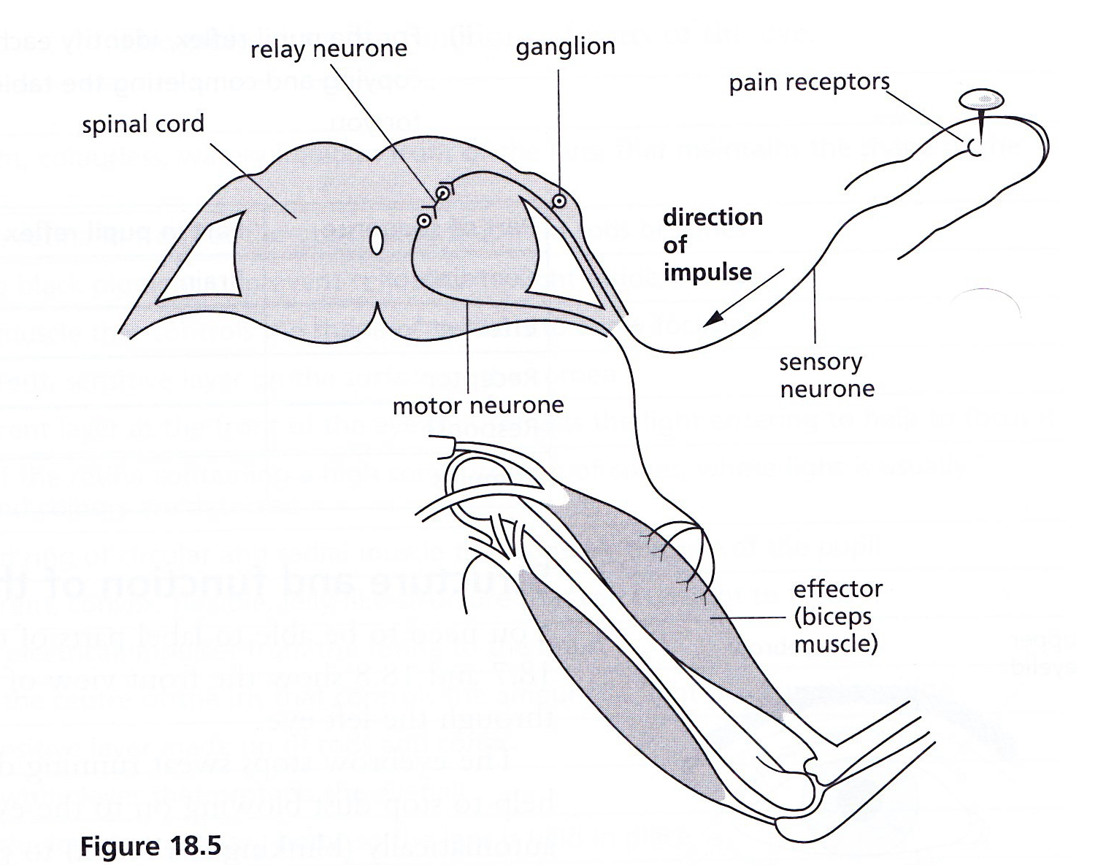
- A reflex arc describes the pathway of an electrical impulse in response to a stimulus;
- In diagram above, the stimulus is a pin sticking in the finger;
- The response is the withdrawal of the arm due to contraction of the biceps;
- Relay neurons are found in the spinal cord, connecting sensory neurons to motor neurons;
- Neurons do not connect directly with each other: there is a gap called a synapse.
- The sequence of events is
Stimulus (sharp pin in finger)

Receptor (pain receptors in skin)

Coordinator (spinal cord)

Effector (biceps muscle)

Response (biceps muscle contracts, hand is withdrawn from pin
2. Describe the structure and function of the eye, including accommodation and pupil reflex.
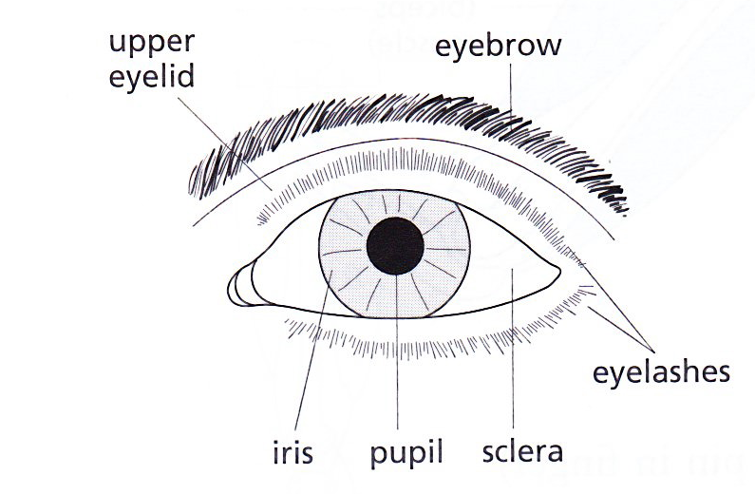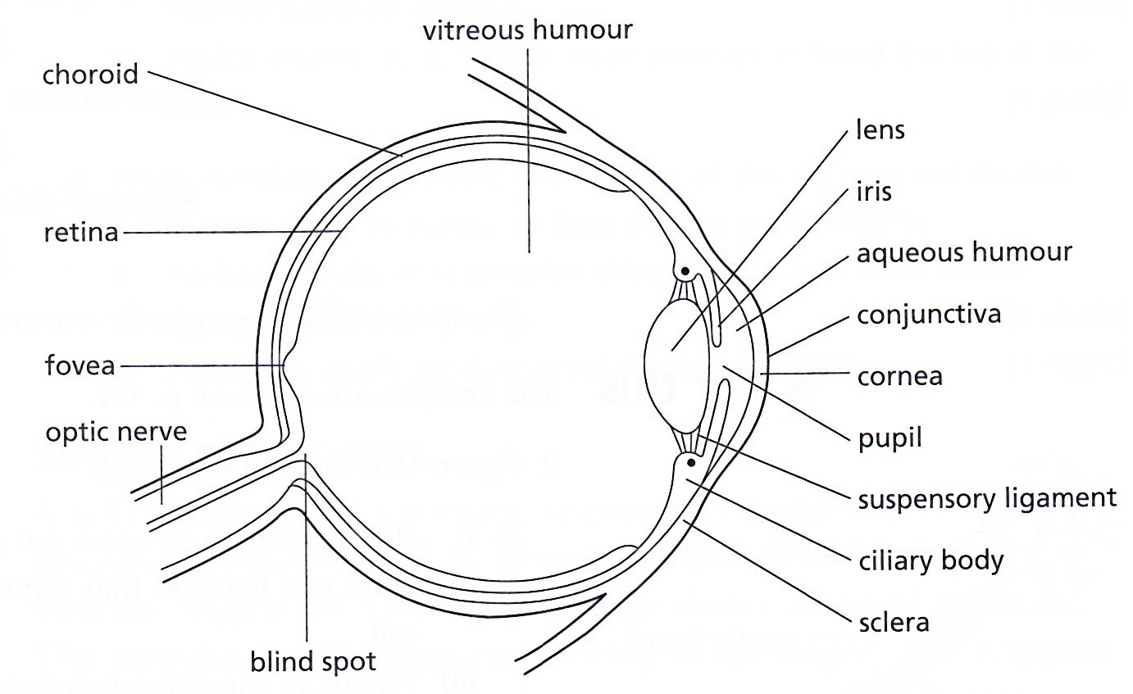
Front view Section through the eye

Part of the eye | Function
Fovea | An area of the retina containing a high concentration of cones, where light is usually focused and colours are detected
Blind spot | Part of the retina in front of the optic nerve that lacks rods or cones
Optic nerve | Transmits electrical impulses from the retina to the brain
Conjunctiva | A transparent, sensitive layer on the surface of the cornea
Sclera | A tough, white layer that protects the eyeball
Choroid | Produces a black pigment to prevent reflection of light inside the eye
Retina | A light sensitive layer made of rods and cones
Ciliary body | A ring of muscle that controls the shape of the lens to allow focusing
Suspensory ligament | Attaches the lens to the ciliary body, so the lens is held in place
Cornea | A transparent layer at the front of the eye that refracts the light entering to help to focus it
Iris | A coloured ring of circular and radial muscle that controls the size of the pupil
Lens | A transparent, convex, flexible, jelly-like structure that refracts light to focus it
Pupil | A hole in the centre of the iris that controls the amount of light reaching the retina
Rods | Sensitive to dim light, do not respond to colour
Cones | Function when the light is bright, able to distinguish between different colours of light

PUPIL (or iris) REFLEX (an e.g. of reflex action)
- This reflex action changes the size of the pupil to control the amount of light entering the eye
- In bright light:
- Retina detects the brightness of light entering the eye;
- An impulse passes to the brain along sensory neurons and travels back to the muscles of the iris along motor neurons, triggering a response:
- Circular muscles contract; radial muscles relax; so iris gets bigger
- Pupil constricts (gets smaller) so less light falls on the retina (to prevent damage).

- In dim light:
- Retina detects the brightness of light entering the eye;
- An impulse passes to the brain along sensory neurons and travels back to the muscles of the iris along motor neurons, triggering a response:
- Radial muscles contract; circular muscles relax; so iris gets smaller
- Pupil size is increased (dilated) to allow as much light as possible to enter the eye;

ACCOMMODATION
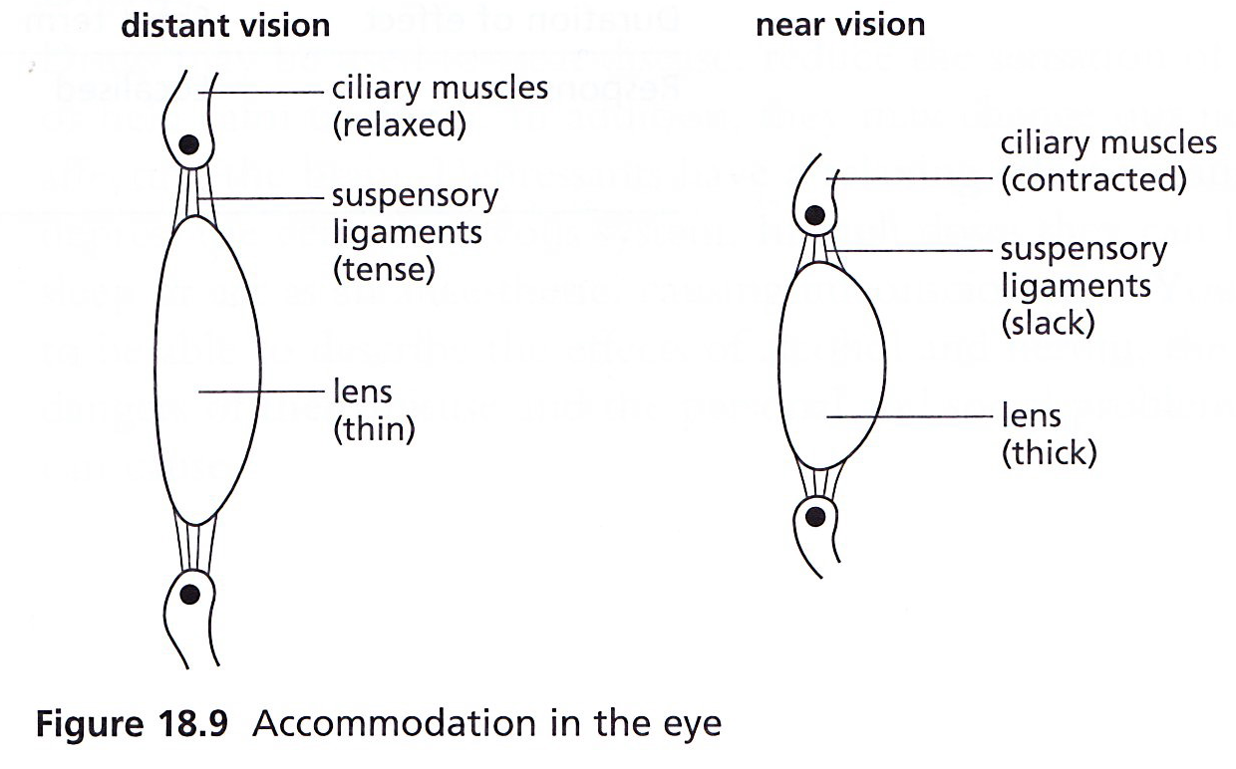
To focus on a distant object | To focus on a nearby object
Slightly diverging rays of light enter the eye | Greatly diverging rays enter the eye
Ciliary muscles relax | Ciliary muscles contract
Suspensory ligaments are pulled tight | Suspensory ligaments slacken (loosen)
Lens becomes thin | Lens get fatter
The thin lens bends the light rays slightly | The thick lens bends the light rays greatly

