B8 - REPRODUCTION
8.2 - Sexual reproduction in plants

1. Identify and draw, using a hand lens if necessary, the sepals, petals, stamens, anthers, carpels, ovaries and stigmas of one locally available, named insect-pollinated, dicotyledonous flower, and examine the pollen grains under a light microscope or photomicrographs.
Insect pollinated, dicot. flower.
And the pollen grains.
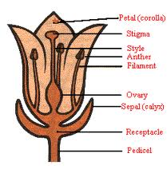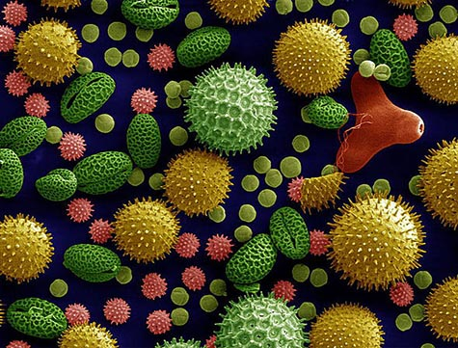
2. Use a hand lens to identify and describe the anthers and stigmas of one locally available, named, wind-pollinated flower.
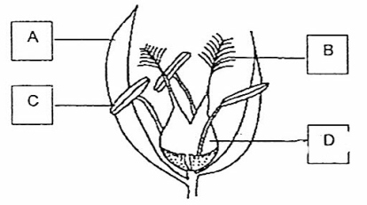
Figure showing wind-pollinated flower
A-Bract,
B-Feathery stigma,
C-Anther loosely attached to the filament, D- Ovary
3. State the functions of the sepals, petals, anthers, stigmas and ovaries.

Part | Function
Petal | Often large and coloured, to attract insects
Sepal | Protects the flower while in bud
Petiole (stalk) | Supports the flower to make it easily seen by insects, and to be able to withstand wind
Stamen | The male reproductive part of the flower, made of anther and filament
Anther | Contains pollen sacs, in which pollen grains are formed. Pollen contains male sex cells
Filament | Supports the anther
Carpel | The female reproductive part of the flower, made of stigma, style and ovary
Stigma | A sticky surface that receives pollen during pollination
Style | Links the stigma to the ovary, through which pollen tubes grow
Ovary | Contains ovules, which develop into seeds when fertilised
4. Candidates should expect to apply their understanding of the flowers they have studied to unfamiliar flowers.
5. Define pollination.
Transfer of pollen grains from the male part of the plant (anther) to the female part (stigma).
6. Name the agents of pollination.
Wind; Animals including insects; Water
7. Compare the different structural adaptations of insect-pollinated and wind-pollinated flowers.
Feature | Insect-pollinated | Wind-pollinated
Petals | Present- often large, coloured and scented | Absent or small and inconspicuous
Nectar | Produced by nectaries to attract insects | Absent, or small and green
Stamen | Present inside the flower | Long filaments, allowing the anthers to hang freely outside the flower so the pollen is exposed to the wind
Stigmas | Small surface area, inside the flower | Large and feathery, hanging outside the flower to catch pollen
Pollen | Smaller amounts- grains are often round and sticky, or covered in spikes to attach to the furry bodies of insects | Larger amounts of smooth and light pollen grains, which are easily carried by the wind
Bracts (modified leaves) | Absent | Sometimes present

8. Investigate and state the environmental conditions that affect germination of seeds: requirement for water and oxygen, suitable temperature.
IGCSE Biology (Jones & Jones), p.190, activity 13.4 – ‘to find the conditions necessary for the germination of tomato seeds’.
Environmental conditions affecting germination

Environmental condition | Explanation
Water | Absorbed through micropyle, needed to activate enzymes which convert insoluble food stores into soluble foods needed for growth and energy production.
Oxygen | Needed for respiration, to release energy for growth and chemical changes for mobilization of food reserves
Suitable temperature | For enzymes to work as enzymes work best at optimum temperature
Light | Not usually a requirement for germination but some seeds need a period of exposure to light before they germinate

9. Investigate and describe the structure of a non-endospermic seed in terms of the embryo (radicle, plumule & cotyledons) and testa, protected by the fruit.
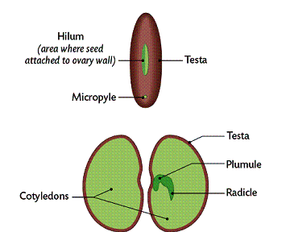
- After fertilization, the ovule becomes a zygote;
- The zygote divides by mitosis to form an embryo plant;
- The ovule is now called a seed;
- The ovary becomes the fruit.

Part of the seed | Structure | Function
Testa | Tough protective covering | Stop embryo from being damaged, prevents bacteria and fungi from entering the seed
Cotyledons | Food store | Contains starch, protein and enzymes
Radicle | Part of embryo | Grow into root
Plumule | Part of embryo | Grow into shoot
Micropyle | Tiny hole in testa | Water and oxygen enters the seed through this hole
Hilum | A scar near the micropyle | Where the seed was joined to the pod (ovary)

10. State that seed and fruit dispersed by wind and by animals provides a means of colonizing new areas.
- Dispersal of seeds is important, because it prevents too many plants growing close together;
- If this happens, they compete for light, water and nutrients, so that none can grow properly;
- Dispersal also allows the plant to colonise new areas.

11. Describe, using named examples, seed and fruit dispersed by wind and by animals.

Wind dispersed fruit
Dandelion  - Dandelion fruit has a group of fine hairs called a pappus;  - Pappus acts as a parachute and catches wind;  - The fruit counterbalances the pappus. | 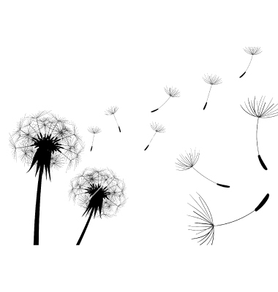
Sycamore  - Sycamore has a wing with a large surface area;  - When fruit drops of the tree it spins, slowly down its descent;  - If caught by wind the seed will be carried away from the parent plant, reducing competition for nutrients, water and light. | 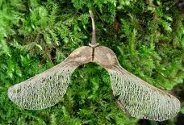

Animal dispersed fruit
Succulent fruits e.g. blackberry  - They are coloured, juicy and nutritious and hence attracted by animals;  - When eaten seeds pass through the gut without getting digested and deposited with animal faeces far away from the parent plant. | 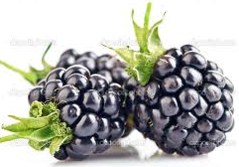
Hooked fruits e.g. bur  - Catch on to animal’s fur as it brushes past the parent plant;  - Eventually the seed drop off and gets dispersed far away from the parent plant. | 