B9 - INHERITANCE
9.1 - Chromosomes & Genes

1. Define inheritance
The transmission of genetic information from generation to generation.

2. Define the terms
a. Chromosome as a thread of DNA, made up of a string of genes.
b. Gene as a length of DNA that is the unit of heredity and codes for a specific protein. A gene may be copied and passed on to the next generation.
c. Allele as any of two or more alternative forms of a gene.

3. Define the terms:
a. Haploid nucleus as a nucleus containing a single set of unpaired chromosomes (e.g. sperm and egg).
b. Diploid nucleus as a nucleus containing two sets of chromosomes (e.g. in body cells).

4. Describe the inheritance of sex in humans (XX and XY chromosomes).
- Of the 23 pairs of chromosomes present in each human cell, one pair is the sex chromosome;
- These determine the sex of the individual;
- Males have XY, and females have XX.

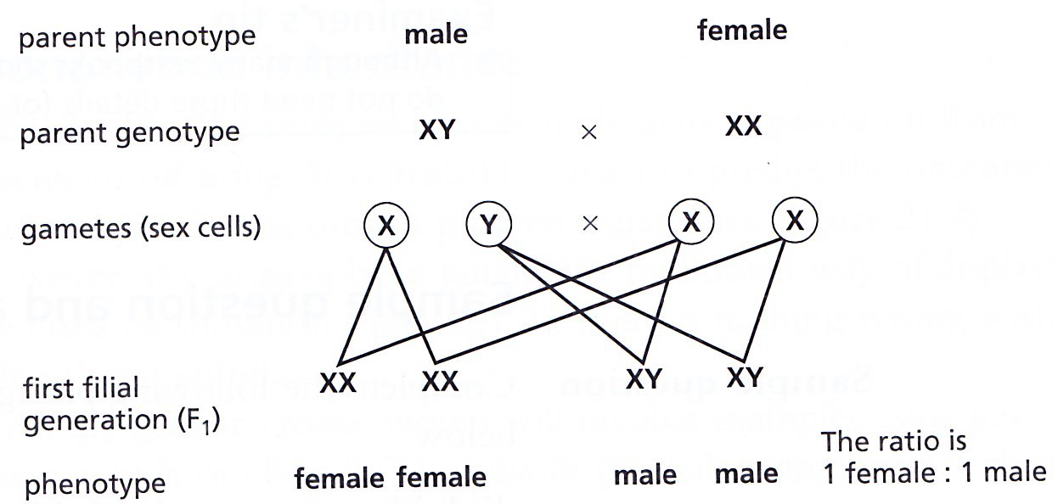

9.2 - CELL DIVISION

1. Define mitosis
As nuclear division giving rise to genetically identical cells in which the chromosome number is maintained by the exact duplication of chromosomes.

2. State the role of mitosis
- Helps in growth;
- Repairs damaged tissues;
- Replaces worn out cells;
- Asexual reproduction.

3. Define meiosis.
As a reduction in which the chromosome number is halved from diploid to haploid.

4. State that gametes are the result of meiosis.
Gametes are the result of meiosis, which on fertilization helps to retain the chromosome number specific for a species.
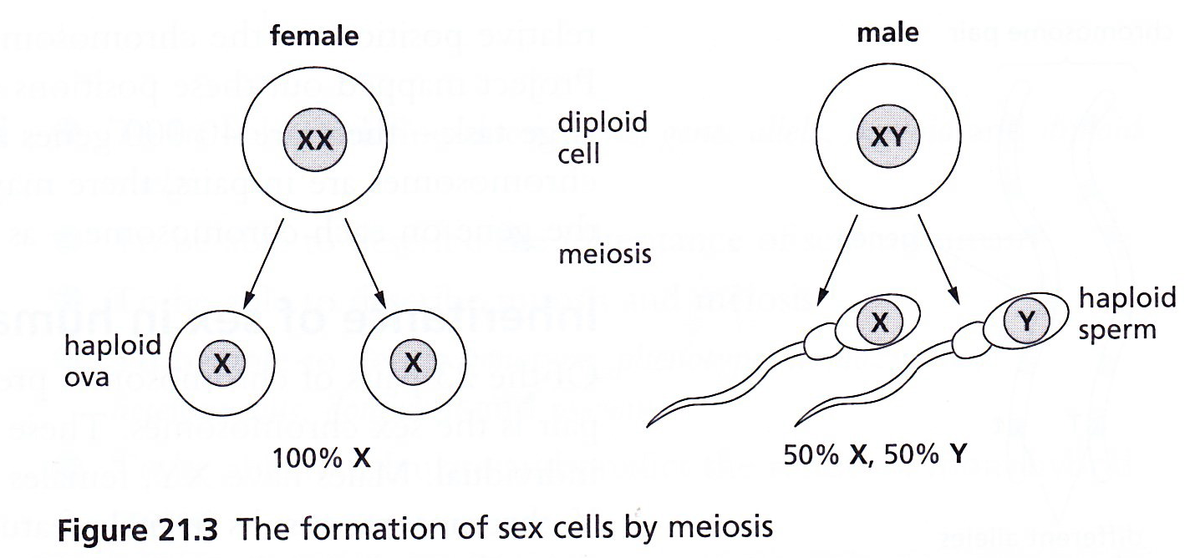

5. State that meiosis results in genetic variation so the cells produced are not all genetically identical.
- Sex cells are formed in the gonads (ovaries and testes) by meiosis;
- The gametes (sex cells) produced are haploid, but they are formed from diploid cells;
- Thus meiosis involves halving the normal chromosome number;
- At the end of the process, cells produced are not all identical, thus meiosis results in variation.

9.3- MONOHYBRID INHERITANCE
1. Define the terms
a. Genotype as the genetic makeup of an organism in terms of the alleles present (Tt or GG).
b. Phenotype as the physical or other features of the organism due to both its genotype and its environment (e.g. tall plant or green seed).
c. Homozygous as having two identical alleles of a particular gene (TT or gg). Two identical homozygous individuals that breed together will be pure-breeding.
d. Heterozygous as having two different alleles of a particular gene (e.g. Tt or Gg), not pure- breeding.
e. Dominant as an allele that is expressed if it is present (e.g. T or G).
f. Recessive as an allele that is only expressed if homozygous (e.g. t or g).

2. Calculate and predict the results of monohybrid crosses involving 1:1 and 3:1 ratios.

Monohybrid inheritance involves the study of how a single gene is passed on from parents to offspring.
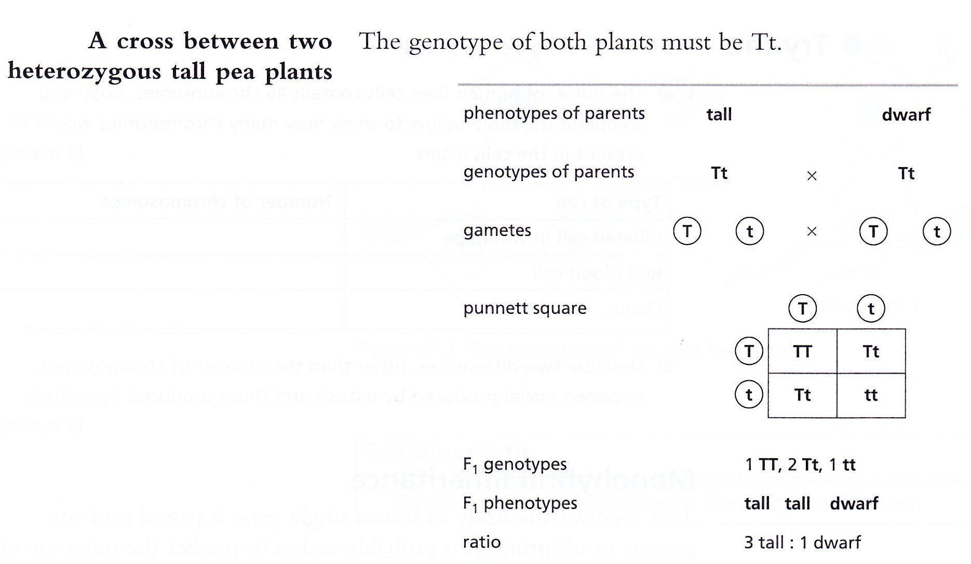

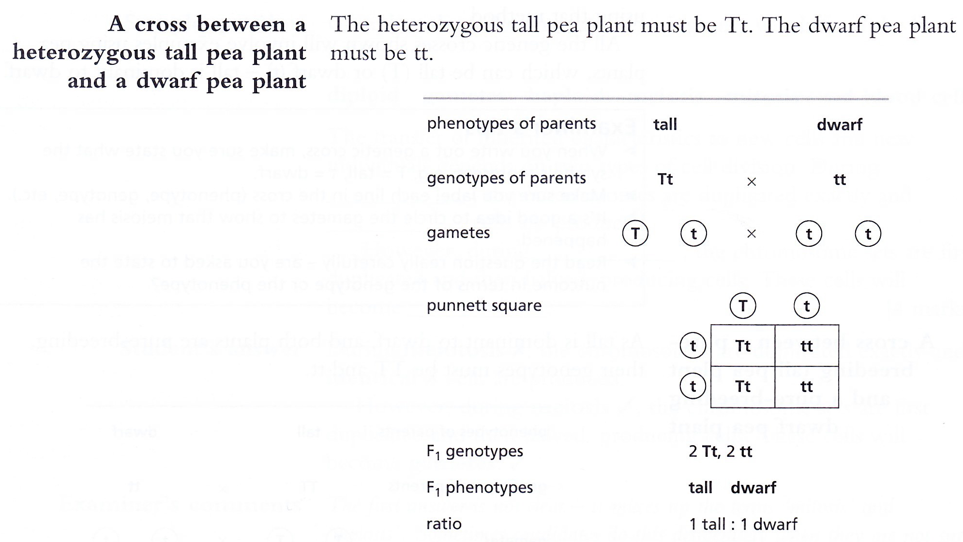

9.4 - VARIATION AND SELECTION

- State that continuous variation is influenced by genes and environment, resulting in a range of phenotypes between two extremes e.g. height in humans.
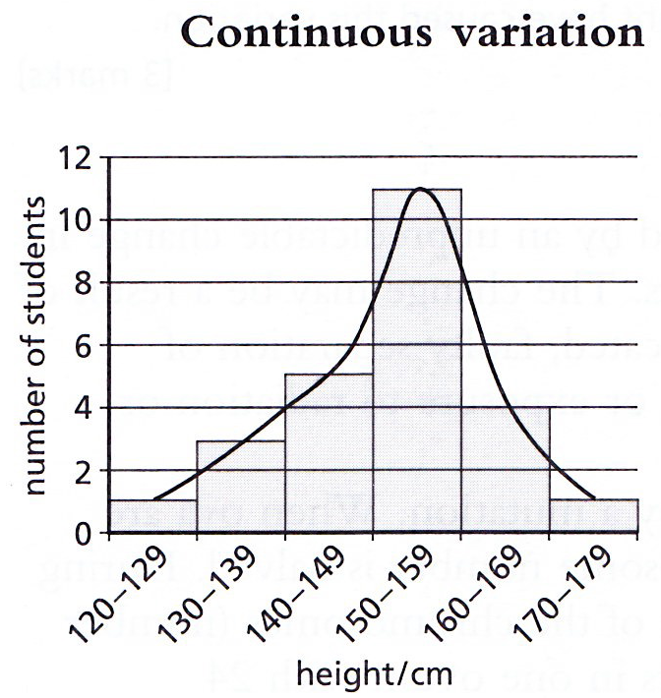

- Continuous variation is caused both by genes and by environment;
- Environmental influences for plants may be competition for nutrients, light, water and exposure to disease;
- For animals, it may be availability of food and exposure to disease;
- Examples of continuous variation include height, body mass and intelligence.

- State that discontinuous variations caused by genes alone and results in a limited number of distinct phenotypes with no intermediates e.g. A, B, AB, and O blood groups in humans.
- Discontinuous variation is seen where there are obvious, distinct categories for a feature;
- There are no intermediates between categories, and the feature cannot usually change during life;
- It is caused by a single gene or a small group of genes, with no environmental influence;
- Examples include blood group, ability to tongue-roll and earlobe shape.
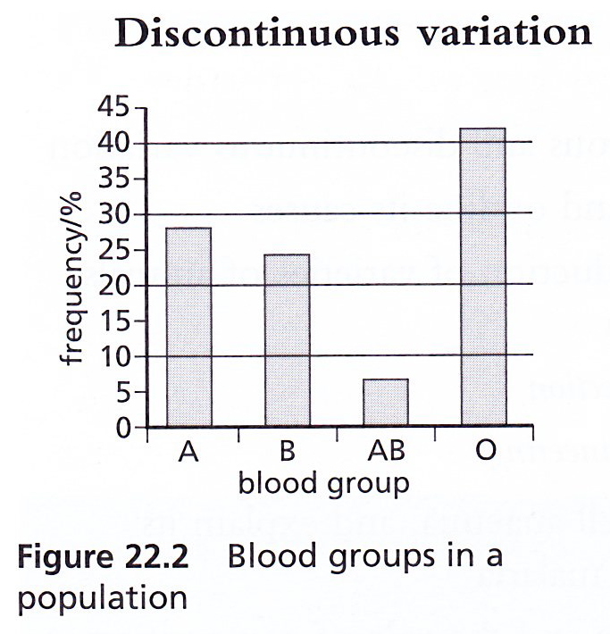

- Define mutation
As a change in a gene or chromosome.

- Outline the effects of ionizing radiation on the rate of mutation.
- Exposure to radiation and some chemicals, such as tar in tobacco smoke, increases the rate of mutation;
- Exposure can cause uncontrolled cell division, leading to the formation of tumours (cancer);
- Exposure of gonads (testes and ovaries) to radiation can lead to sterility or damage to genes in sex cells that can be passed on to children.

- Describe the role of artificial selection in the production of varieties of animals and plants with increased economic importance.
- Artificial selection is used by humans to produce varieties of animals and plants that have an increased economic importance.
- Process involves
- (a) Breeder selects two varieties of a species which have characteristics of interest;
- (b) Then they breed them together;
- (c) Then they select their offspring which shows characteristics of interest and breed them;
- (d) The process of breeding is continued over many generations until the entire population shows the characteristics of interest.

- Examples:

- (i) A variety of cattle may have a higher than average milk yield. Another variety may have a very high milk yield. If the two varieties are crossbred, a new breed could be artificially produced that has the benefits of both parental varieties (high milk production in females; high meat yield in males).

- (ii) Wild varieties of plants sometimes have increased resistance to fungal diseases, but have poor fruit yield. Crossbreeding wheat plants can result in the formation of varieties that have both high resistance to disease and high seed yield.

- Describe variation and state that competition leads to differential survival of, and reproduction by, those organisms’ best fitted to the environment.
- Variation describes differences in a population;
- Some variation is inherited (passed on from parents) and some is acquired (developed during life);
- Animals and plants produced by sexual reproduction will show variation from their parents, e.g. in the size of muscles in the legs of lion;
- Some slight variations may better adapt some organisms to their environment than others;

- The process of natural selection follows a sequence, listed below:
- Overproduction: Most organisms produce more young than will survive to adulthood.
- Struggle for existence: When new organisms are produced, not all of them are likely to survive because of competition for resources such as food, water and shelter;
- Survival of the fittest: The individuals with the most favourable characteristics are most likely to survive;
- Advantageous characteristics passed on to offspring: Only the well adapted organisms will be able to reproduce successfully and pass on their advantageous genes to their offspring.

- Define natural selection
As the greater chance of passing on of genes by the best-adapted organisms.

- Explain the importance of natural selection as a possible mechanism for evolution.
- The theory of natural selection suggests that the best-adapted organisms are selected to pass on their characteristics to the next generation;
- In this way, over a period of time, the population will lose all the poorly adapted individuals;
- Thus the population will gradually become better adapted to the environment.
- This gradual change in the species through natural selection over time, in response to changes in the environment, is a possible mechanism for evolution.

- Describe the development of strains of antibiotic resistant bacteria as an example of natural selection.
- Bacteria reproduce rapidly- a new generation can be produced every 20 minutes;
- Antibiotics (is a chemical that kills bacteria by preventing bacterial cell wall formation) are used to treat bacterial infections;
- Mutations occur during reproduction, which produce some variation in the population of bacteria;
- Individual bacteria with the most favourable features are most likely to survive and reproduce;
- A mutation may occur that enables a bacterium to resist being killed by antibiotic treatment, while the rest of the population is killed when treated;
- This bacterium would survive the treatment and breed, passing on the antibiotic-resistant gene to its offspring;
- Future treatment of this population of bacteria using the antibiotic would be ineffective.

